Validated high-throughput screening with simplex-constrained surrogates for CALPHAD phase-fraction prediction
Sina Mousavi^{a*}, Narinderjit Singh Sawaran Singh^{b}, Darya Ahmadova^{c}, Sandeep Sharma^{d,e}, Sanjeev Singh^{f,g}, Qasem Kharma^{h}
a Department of Computer Science Faculty of Statistics, Mathematics and Computer Science Allameh Tabataba'i University Tehran, Iran;
b Faculty of Data Science andInformation Technology, INTI International University, Persiaran Perdana BBN,Putra Nilai, Nilai, 71800, Negeri Sembilan, Malaysia;
c Azerbaijan State Oil and Industry University, Baku, Azerbaijan, AZ1010;
d Centre for Research Impact and Outcome, Chitkara University, Rajpura- 140417, Punjab, India;
e Center for innovation and inclusive research, Sharda University, Greater Noida, Uttar Pradesh, India;
f Noida Institute of Engineering and Technology, 19, Knowledge Park-II, Institutional Area, Greater Noida (UP)-201324, India.
g Division of research and development, lovely professional University, Phagwara, Punjab, India;
h Department of Software Engineering,Hourani Center for Applied Scientific Research, Al-Ahliyya Amman University, Amman, Jordan.
*Corresponding author, ss_mousavi@atu.ac.ir

Abstract: Machine-learning surrogates accelerate CALPHAD equilibrium calculations by orders of magnitude, but deployment requires three answers: how to predict phase fractions under the simplex constraint, where the predictions can be trusted, and whether screening saves cost. Six neural-network output heads and a presence-gated two-stage head were benchmarked against four classical baselines on 88,542 mass-balance-validated equilibria from nine systems. The nine systems comprise five Fe-based ternaries, a quaternary Fe–Cr–Ni–C system, a carbide Fe–Cr–C system, and two Fe-free ternaries. Structurally constrained heads closed the simplex to machine precision at no accuracy cost. The gated head lifted macro area under the precision–recall curve (macro-AUPRC) to 0.91–0.99 on all nine systems while leading the random forest in MAE. Size-matched and region-matched controls with an ideal-form control showed interior-band penalties are spatial, not volumetric, while strict extrapolation failed on every axis. Ensemble disagreement provided cheap per-row triage inside the trained region. Two validated lean-nickel screens (501,501 and 330,000 compositions; shortlist precision 1.00 and 0.98) paid back data costs several times over. Failed mechanisms (sparsemax, sum-to-one penalty, residue head) delimit the scope.
Keywords: CALPHAD; Machine learning surrogate; Simplex constraint; Spatial generalization; Phase fraction prediction; High-throughput screening.
Highlights:
• Simplex closure to machine precision costs no accuracy; renorm is enough
• Presence supervision, not architecture, resolves sharp phase boundaries
• Interior-band penalties are spatial, not volumetric; extrapolation unsupported
• Lean-nickel screen: 501,501 compositions in 0.4 s, shortlist precision 1.00
• Failed mechanisms delimit the scope: sparsemax, sum-to-one penalty, residue

Introduction
The paradigm of Integrated Computational Materials Engineering (ICME) has fundamentally transformed modern alloy design by treating materials development as a concurrent, requirements-driven engineering process[1, 2]. At its core, ICME establishes tight, multiscale mathematical linkages across the processing–microstructure–property–performance chain, effectively replacing empirical trial-and-error with top-down computational design [2]. Within this framework, computational thermodynamics serves as the foundational connective tissue . The CALPHAD (CALculation of PHAse Diagrams) method provides high-fidelity database resources to predict stable equilibrium phase assemblages, transition temperatures, and thermodynamic properties as a rigorous function of temperature and local multi-component composition [3, 4].
These foundational calculations rely on the numerical minimization of a system's total Gibbs free energy under fixed temperature, pressure, and mass balance constraints [3, 5]. While alternative formulations have extended equilibrium calculations to other physical potentials [5], Gibbs energy minimization remains the standard. However, as metallurgical exploration shifts aggressively toward highly complex spaces—such as advanced high-strength steels [6, 7], multi-component superalloys [8], and high-entropy alloys [9]—computational alloy design is confronted by a massive combinatorial explosion of composition variables. Rigorous iterative equilibrium solvers are highly computationally intensive, often requiring several seconds to converge a single design coordinate [10]. When screening millions of potential chemistry combinations in high-dimensional composition spaces, the cumulative computational cost of raw CALPHAD queries becomes entirely prohibitive [9, 10].
To circumvent the bottlenecks inherent to iterative thermodynamic solvers, machine-learning (ML) surrogate models are increasingly deployed to replace raw CALPHAD queries [11]. These surrogates—ranging from tabular-oriented ensemble decision trees like Random Forests and XGBoost to deep neural networks (DNNs)—execute rapid forward passes that provide computational speedups of three to five orders of magnitude. Such massive acceleration enables the high-throughput screening of vast, multi-million composition databases in minutes rather than months [11, 12].
Despite these clear performance advantages, predicting multi-phase equilibria directly introduces a unique mathematical challenge: the predicted vector of equilibrium phase fractions must strictly reside on the probability simplex. To satisfy fundamental mass conservation laws, the phase fractions ($N_{k}$) for $K$ possible phases must sum to exactly one and remain strictly non-negative [13]:
$$\sum_{k=1}^{K}{N_{k}}=1, N_{k}≥0$$ | (1)

Predictions that violate these structural constraints are physically inadmissible for downstream multiscale models, including kinetic simulations or phase-field modeling [14].
In adjacent fields like geochemistry [15] and agronomy [16], this challenge is addressed through Compositional Data Analysis (CoDA) using log-ratio transformations. In materials informatics, however, the literature exhibits a critical lack of consensus on how to best enforce these physical constraints on neural-network outputs [10]. Some researchers integrate standard softmax layers into multi-phase DNN regressors to natively restrict predictions to a sum of one [10, 13]. Others propose differentiable algorithms, such as DISCOMAX, which utilize straight-through softmax relaxations to guarantee thermodynamic consistency [14].
Conversely, recent deep-learning workflows focusing on complex superalloys found that enforcing a strict 100% sum rule on output heads actually reduced overall predictive accuracy. Consequently, those models defaulted to unconstrained linear outputs, deliberately accepting mass-balance errors to preserve continuous regression performance [17]. Alternative constraint configurations—such as post-hoc renormalization, sparsity-inducing operators like sparsemax, or algebraic residue closure—have been proposed, but their relative tradeoffs regarding predictive accuracy, physical admissibility, and training stability remain unbenchmarked in multi-phase metallurgical settings [14].
The closest adjacent work predicts single-temperature phase labels rather than fraction vectors. Stoco et al. [33] classify single-phase FCC/BCC against multiphase states in a ten-element space, with lever-rule data augmentation for the minority class. This work regresses full fraction vectors across temperature with a structurally enforced simplex. Their blind gridding left 21.5% of points non-converged where the balance element vanishes. Our probe-driven design space with a mass-balance gate avoids that failure mode by construction, at the price of the sampling-coverage confound discussed in the Limitations.
A secondary challenge in materials informatics is the evaluation of models beyond standard random or cluster-stratified cross-validation splits [18, 19]. Conventional protocols primarily assess interpolation ability, where queried test points are surrounded by local training neighbors [20]. Practical alloy discovery, however, frequently requires querying entirely unprobed chemical spaces. This introduces complex spatial generalization challenges: predictions must be made either in contiguous, missing interior regions or under strict out-of-range extrapolation [20, 21].
Evaluating surrogate models under these geometric distribution shifts is confounded by data volume. Removing a specific spatial region to construct a validation task inherently removes training data, making it statistically difficult to isolate the true algorithmic penalty of the spatial shift from the penalty of learning from a reduced dataset. Thus, establishing rigorous spatial generalization protocols utilizing size-matched random controls is mathematically necessary to decouple true spatial shifts from mere data-volume effects.
Furthermore, the architectural behavior of ML algorithms under these geometric shifts is starkly distinct. Tabular-oriented algorithms, such as Random Forests, interpolate systems dominated by sharp, binary phase boundaries well, but their step-function decision boundaries prevent them from predicting continuous trends beyond known ranges [4]. DNNs can produce smoother outputs that generalize more gracefully [4, 22]. Despite this potential, recent studies analyzing over 700 out-of-distribution (OOD) tasks demonstrate that true extrapolation beyond the training domain severely degrades predictive fidelity across all standard architectures [20]. To mitigate these limits, researchers have explored transductive approaches [21] or deep generative flow-based imputers [23]. However, a systematic, decoupled evaluation of spatial generalization limits for direct continuous phase fraction prediction remains absent.
An equally critical, yet often neglected, issue in evaluating CALPHAD surrogates is the regressor–detector gap. Standard validation almost exclusively relies on aggregate regression metrics, such as Mean Absolute Error (MAE) [24, 25]. Because zero-fraction rows mathematically dominate global loss calculations in multi-phase databases, an unconstrained model can achieve a deceptively low aggregate error by predicting near-zero fractions for inactive phases, while entirely failing to accurately resolve the emergence of newly stabilizing, rare phases.
In physical metallurgy, this specific modeling failure has severe real-world consequences. Detrimental intermetallic phases—such as the highly embrittling $σ$-phase in stainless steels—exercise a massively disproportionate influence on the alloy's mechanical toughness and corrosion properties despite small volume fractions [7, 26]. From a machine-learning perspective, standard uniform loss functions do not penalize their misprediction heavily enough to force gradient descent to learn their distinct, narrow thermodynamic boundaries. Consequently, a surrogate minimizing aggregate regression error is not necessarily an optimal phase-presence detector. This gap is robust across classification thresholds, and discrete phase-presence detection capability degrades much faster than continuous regression error under spatial distribution shifts. Resolving this gap is of paramount importance for building engineering trust in ML surrogates.
To address these challenges, this study investigates how neural-network architectures predict multi-phase equilibria under strict mass conservation. The benchmark comprises 88,542 validated thermodynamic equilibria from nine systems: five Fe-based ternaries (Fe–Cr–Ni, Fe–Cr–Mn, Fe–Cr–Mo, Fe–Cr–V, Fe–Mn–Ni), a quaternary Fe–Cr–Ni–C system, a carbide Fe–Cr–C system, and two Fe-free ternaries (Cr–Co–Ni, Cr–Ni–Mn). The limits of deep-learning surrogates are evaluated under distribution shifts, and the pipeline is demonstrated end to end with two validated high-throughput screens. The systems cover metallurgically relevant phases, including the FCC solid solutions of stainless steels and nickel-based superalloys.
The contributions of this work are sixfold. First, six neural-network output configurations are benchmarked against four classical baselines for regression accuracy and physical admissibility. Second, spatial generalization is tested with a contiguous interior-band holdout and a strict one-sided extrapolation task, using size-matched random controls plus a region-matched reanalysis with an ideal-form control to separate spatial penalties from data-volume effects. Third, the regressor–detector gap is characterized and substantially closed with a presence-gated two-stage head. Fourth, ensemble disagreement is evaluated as a cheap per-row error triage. Fifth, the full protocol is re-run on four scope-extension systems. Finally, the pipeline is validated end to end with two high-throughput lean-nickel screens and a four-point experimental anchor, and negative results for three constraint mechanisms are reported as design guidelines.

Methods
Figure 1 summarises the pipeline end to end: the CALPHAD data generation, the fixed-protocol split and model families, and the three evaluation protocols they are subjected to.
Figure 1. Study pipeline. (1) CALPHAD data generation: five Fe-based ternary subsystems are extracted from the open MatCalc steel database, probe-driven phase sets fix the target dimensionality, structured sampling draws 11,220 candidate points per system, and a mass-balance gate accepts 44,397 equilibria in total; four scope-extension systems (quaternary Fe–Cr–Ni–C, Fe–Cr–C, and Fe-free Cr–Co–Ni and Cr–Ni–Mn) reuse the same pipeline and add 44,145 equilibria (88,542 in total). (2) A cluster-stratified 64/16/20 split feeds a constrained MLP with six fraction-only heads and a presence-gated two-stage head, plus four classical baselines, all fitted under one fixed protocol and three seeds. (3) Three evaluation protocols — interpolation, contiguous interior-band holdout, and strict one-sided extrapolation, the two spatial ones each with a size-matched random control — plus secondary analyses (ablations, boundary-error analysis, region-matched reanalysis with an ideal-form control, and uncertainty screening, dashed arrows). (4) Deployment: a four-point experimental anchor and two validated high-throughput screens (a 501,501-composition ternary screen and a 330,000-composition quaternary screen), with ensemble disagreement gating the ternary screen.

Data Generation

Thermodynamic Description
All thermodynamic equilibrium calculations were driven by the open MatCalc steel database [35] (mc_fe_v2.062). To ensure computational compatibility, a custom lenient parser was integrated with pycalphad [34] to extract the relevant five ternary subsystems (Fe–Cr–Ni, Fe–Cr–Mn, Fe–Cr–Mo, Fe–Cr–V, and Fe–Mn–Ni) and implement minor syntax corrections. A rigorous validation step was performed on a pruned version of the database; this verified strict equivalence with the unpruned source, ensuring maximum deviations in phase fractions and Gibbs free energies remained strictly at zero across all systems. For all generated equilibria, the system pressure was fixed at 101,325 Pa.

Probe-driven Phase Sets
Running complete equilibrium calculations with all eligible phases is computationally intensive, averaging roughly 2.5 seconds per query point. To streamline dataset generation, a transductive probing strategy was employed. Each of the five systems was independently sampled using 2,000 Dirichlet draws to identify which phases were actively present. As detailed in Table 1, only phases observed to be active during this probing phase were retained as regression targets, dramatically reducing the dimensionality ($K$) from the total eligible phases. This global preprocessing step definitively fixed the output dimensionality for each system prior to any predictive modeling. The fidelity of this phase-set reduction was strictly validated on an independent set of 1,500 points, confirming that the targets maintained mass-balance closure within the solver's tolerance bounds ($|\sum_{k}{y_{k}}-1|≤3.3×{10}^{-8}$).
Table 1. Summary of the investigated ternary systems, contrasting the total number of theoretically eligible phases against the verified probe-active target phases ($K$) utilized as regression targets in this study.

System | x₂, x₃ | Eligible | K | Target phases
Fe–Cr–Ni | Cr, Ni | 28 | 4 | BCC_A2, FCC_A1, LIQUID, SIGMA
Fe–Cr–Mn | Cr, Mn | 31 | 7 | ALPHA_MN, BCC_A2, BETA_MN, CR3MN5, FCC_A1, LIQUID, SIGMA
Fe–Cr–Mo | Cr, Mo | 29 | 9 | BCC_A2, CHI_A12, FCC_A1, LAVES_PHASE, LIQUID, MU_PHASE, MU_PHASE_I, R_PHASE, SIGMA
Fe–Cr–V | Cr, V | 25 | 4 | BCC_A2, FCC_A1, LIQUID, SIGMA
Fe–Mn–Ni | Mn, Ni | 29 | 7 | ALPHA_MN, BCC_A2, BETA_MN, FCC_A1, LIQUID, MNNI, MNNI2

Sampling and Acceptance
The design variables for each system comprised two independent mole fractions ($x_{2}$ and $x_{3}$), with iron serving as the balance element ($x_{Fe}=1-x_{2}-x_{3}$), and temperature ($T$) sampled uniformly across the 700 to 2000 K domain. To prevent the systematic undersampling of metallurgically critical regions, five deterministic sampling strategies were combined to generate 11,220 candidate points per system. This approach deliberately over-represented the iron-rich corner, isothermal slices, the liquidus zone, and sigma-phase fields. A candidate data point was only incorporated into the final dataset if its composition resided within the defined sub-simplex and its computed equilibrium satisfied a stringent mass-balance tolerance ($|\sum_{k}{N^{k}}-1|<{10}^{-6}$). This acceptance protocol yielded robust datasets of approximately 8,880 convergent rows per ternary system, the statistical compositions of which are summarized in Table 2. The spatial distribution, phase occurrences, and structural closure bounds of this generated data are further visualized in Figure 2.
Table 2. Summary statistics of the generated datasets across the five Fe-based ternary systems, detailing phase occurrence boundaries and maximum deviations in mass-balance simplex closure.
System | Rows | Box (%) | max|Σy−1| | K | Occurrence range (%)
Fe–Cr–Ni | 8,880 | 38.0 | 9.8×10⁻⁹ | 4 | 11.94–73.6
Fe–Cr–Mn | 8,880 | 38.0 | 1.2×10⁻⁸ | 7 | 0.03–57.5
Fe–Cr–Mo | 8,877 | 38.0 | 3.3×10⁻⁸ | 9 | 0.10–63.5
Fe–Cr–V | 8,880 | 38.0 | 1.9×10⁻⁸ | 4 | 2.04–79.9
Fe–Mn–Ni | 8,880 | 38.0 | 1.9×10⁻⁹ | 7 | 0.00–76.0

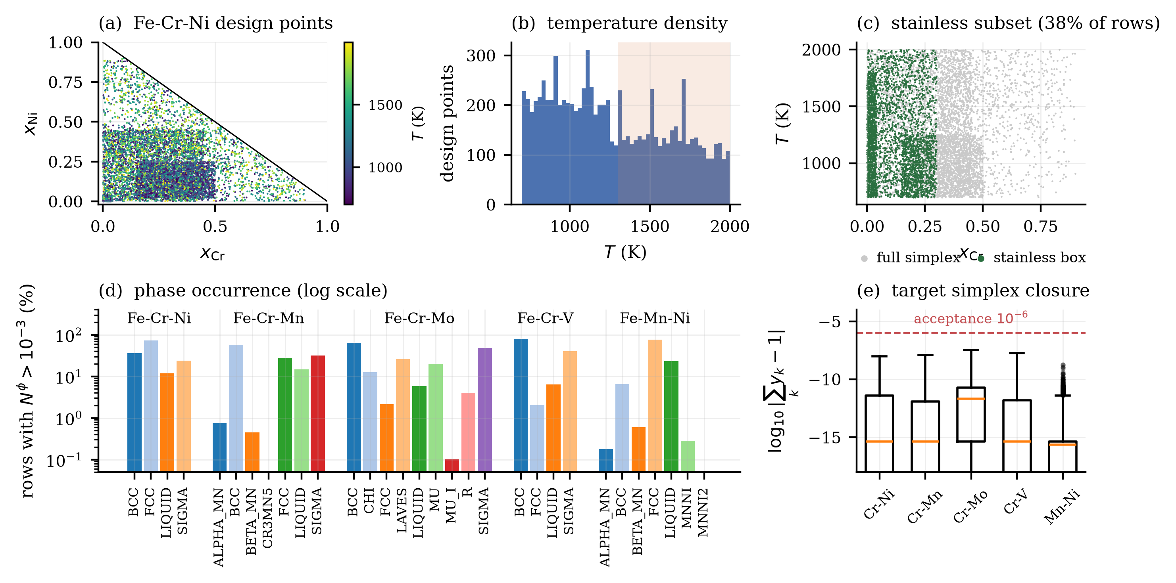
Figure 2. Statistical overview of the generated datasets, with a detailed spatial visualization of the Fe–Cr–Ni system. (a) Design points in the composition plane colored by temperature. (b) Marginal density of sampled temperatures. (c) Demarcation of the industrially relevant stainless-steel subset. (d) Logarithmic frequency of target phase occurrences across all five systems. (e) Verification of mass-balance closure for target vectors prior to model training.

Scope-Extension Datasets
Four additional systems test whether the conclusions survive changes of dimension and chemistry under the identical probe, acceptance, and split protocol. The quaternary Fe–Cr–Ni–C system adds interstitial carbon (13,192 accepted rows; 9 active phases among 35 eligible, including M23C6, M7C3, CEMENTITE, and GRAPHITE). The ternary Fe–Cr–C system contributes 13,199 rows with 9 active phases among 32, with SIGMA in only 0.4% of rows. Two Fe-free ternaries reuse the identical ternary protocol: Cr–Co–Ni (8,874 rows; 5 active among 23; HCP_A3 rarest at 0.7%) and Cr–Ni–Mn (8,880 rows; 9 active among 30, including Mn intermetallics). Together the nine datasets contain 88,542 mass-balance-validated equilibria.

Models and Training

Neural-Network Architectures and Simplex Constraints
The core predictive model was a multilayer perceptron (MLP) featuring three hidden layers composed of 192 units each, integrated with LayerNorm, SiLU activations, and dropout regularization. Networks were trained via the AdamW optimizer employing cosine annealing, early stopping, and a Huber loss function ($Δ=0.01$). Features were standardized using scalers strictly fitted to the training partitions.
To rigorously assess the enforcement of the mass-balance constraint (Eq. 1), six distinct output heads were benchmarked:
- An unconstrained sigmoid baseline.
- A standard softmax projection.
- A train-time sigmoid/$Σ$ normalization.
- A renorm head applying a sigmoid followed by clipping and post-hoc row-sum division.
- A sparsemax operator designed to produce exact zeros for absent phases.
- A residue closure head that algebraically infers the final phase fraction to enforce sum-to-one equality. Crucially, these models were evaluated not just for closure (summing to one) but for strict simplex membership (closure combined with strict non-negativity across all phase components).

Presence-Gated Two-Stage Head
To close the regressor–detector gap, a presence-gated two-stage head was evaluated under the same fixed protocol. A shared 3×192 trunk feeds two per-phase heads: a fraction head (per-phase sigmoid outputs with inverse-prevalence phase-weighted Huber loss) and a presence head (per-phase logits with class-weighted binary cross-entropy at the 10⁻³ presence threshold). The prediction is the elementwise product of the two sigmoid outputs, followed by clip-and-renormalize projection at evaluation. A weighted-only ablation trains just the fraction head to isolate the contribution of presence supervision.

Baseline Models
To contextualize the neural network performance, four classical machine learning baselines were evaluated: ridge regression, distance-weighted $k$-nearest neighbors ($k=10$), XGBoost, and random forests. Because classical regressors do not intrinsically respect structural simplex constraints, each baseline was evaluated both in its raw predictive state and following post-hoc renormalization to yield physically admissible outputs.

Splitting Protocols and Evaluation Metrics
For standard interpolation evaluations, data points were divided using a cluster-stratified KMeans split ($k=6$) to generate representative training (64%), validation (16%), and testing (20%) sets across the three-dimensional feature space. To account for stochastic training variance, all experiments were averaged over three distinct random initialization seeds. The primary continuous evaluation metric was the mean absolute error (MAE) computed across all phases. Phase-presence detection capabilities were additionally quantified using $F_{1}$ scores and balanced accuracy, treating any phase with a predicted fractional presence exceeding ${10}^{-3}$ as physically active. All reported metrics are computed on the test partition, which played no role in training or early stopping. A phase with no active row in a given test set (MNNI2, with zero active rows in the whole Fe–Mn–Ni dataset) has an undefined $F_{1}$; we score it as $F_{1}$ = 0 for every model, which keeps the phase in the average without favoring any model. Table 6 additionally reports an entropy-weighted MAE, an auxiliary metric intended to up-weight multi-phase coexistence states, where several nonzero phase fractions must be predicted simultaneously; it is an evaluation aid, not a theoretically privileged loss.

Spatial Generalization Evaluation Protocols
To explicitly test the spatial generalization and extrapolation limits of the surrogate models, two customized data splitting protocols were devised and executed in addition to the standard interpolation split:
- Contiguous Interior-Band Holdout: This protocol removed a specific temperature band (1200–1400 K) and a composition band ($x_{2}∈\left[0.25,0.35\right]$) entirely from the training data. Delaunay triangulation confirmed that 99.3–99.4% of these held-out points remained within the convex hull of the surrounding training data, framing this as an in-hull distribution shift rather than strict extrapolation.
- Strict One-Sided Extrapolation: To test true out-of-range predictive capacity, models were trained exclusively on one side of a coordinate boundary (e.g., $x_{2}≤0.25$) and tested strictly on the unobserved far side (e.g., $x_{2}>0.35$).
A fundamental challenge in measuring spatial generalization is that removing a geometric region concurrently reduces the sheer volume of available training data. To deconvolve the spatial penalty from this data-volume penalty, both spatial protocols were evaluated alongside strictly sized-matched random controls. In these controls, an equivalent number of training rows were randomly excised across the entire domain, ensuring that any excess predictive degradation observed in the spatial holdouts was genuinely attributable to the domain shift rather than simple data scarcity. As a complementary reference, a region-matched reanalysis is also reported: for each band, the band-holdout error is compared against the main-study models on the identical band rows inside the interpolation test set. Its residual confound is a roughly 15% training-size difference. The ideal-form control removes it by retraining at equal size: band rows kept in training, with an equal number of random non-band rows dropped instead, on identical test rows.

Results

Predictive Accuracy on the Interpolation Split
The primary predictive performance of the evaluated surrogate models on the standard interpolation test sets is summarized in Table 3 and visualized in Figure 3. The comparative analysis reveals that no single architecture universally dominates across the five tested ternary systems. Instead, model superiority is strongly correlated with the underlying topological features of each phase diagram.
Constrained multilayer perceptrons (MLPs) demonstrated superior performance on systems characterized by extended, smooth multiphase coexistence fields. For the Fe–Cr–Ni system, the constrained renorm MLP achieved a mean absolute error (MAE) of 0.0106 ± 0.0006, significantly outperforming the random forest baseline (0.0180 ± 0.0002), representing a 41% reduction in error. A similar advantage was observed in the Fe–Cr–Mn system utilizing the sigmoid/Σ head. Conversely, tree-based models exhibited superior accuracy in systems dominated by sharp, essentially binary phase boundaries. In the Fe–Mn–Ni system, the random forest achieved an MAE of 0.0058 ± 0.0003, outperforming the best constrained MLP (0.0140 ± 0.0013). The Fe–Cr–Mo system resulted in a statistical tie between the two modeling paradigms, which was formally confirmed via paired bootstrap resampling over 10,000 iterations (Table 4).
Furthermore, the application of post-hoc renormalization to classical baseline models did not degrade predictive accuracy in any of the five evaluated systems; in fact, the projection reliably recovered valid states and marginally improved the error metrics.
Table 3. Interpolation test MAE across the five ternary systems, averaged over three random initialization seeds. Neural network heads are categorized by their structural adherence to the simplex constraint. Standard deviations are provided in the least significant digits.
Group | Model | Fe–Cr–Ni | Fe–Cr–Mn | Fe–Cr–Mo | Fe–Cr–V | Fe–Mn–Ni
off-simplex | sigmoid (unconstrained) | 0.0232 (10) | 0.0163 (1) | 0.0184 (5) | 0.0287 (4) | 0.0231 (13)
off-simplex | residue, y(d) = 1−Σ | 0.0229 (3) | 0.0186 (4) | 0.0182 (5) | 0.0254 (3) | 0.0210 (12)
on-simplex | sparsemax | 0.0444 (229) | 0.0212 (177) | 0.0573 (427) | 0.0304 (161) | 0.0375 (295)
on-simplex | softmax | 0.0130 (3) | 0.0088 (11) | 0.0148 (1) | 0.0167 (2) | 0.0145 (15)
on-simplex | sigmoid/Σ (train-time) | 0.0112 (10) | 0.0074 (2) | 0.0126 (2) | 0.0153 (4) | 0.0145 (20)
on-simplex | sigmoid + renorm (post hoc) | 0.0106 (6) | 0.0081 (4) | 0.0159 (3) | 0.0149 (4) | 0.0140 (13)
on-simplex | power-normalisation (†) | 0.0123 (14) | — | — | — | —
baselines | ridge | 0.2053 (9) | 0.1399 (5) | 0.1244 (6) | 0.1940 (8) | 0.0769 (5)
baselines | k-NN, k = 10 | 0.0256 (6) | 0.0171 (5) | 0.0151 (6) | 0.0222 (5) | 0.0091 (6)
baselines | XGBoost | 0.0212 (6) | 0.0154 (8) | 0.0137 (2) | 0.0179 (3) | 0.0081 (3)
baselines | random forest | 0.0180 (2) | 0.0133 (5) | 0.0123 (2) | 0.0137 (4) | 0.0058 (3)

Table 4. Paired bootstrap statistical comparison of row-wise MAE differences between the best-performing constrained MLP and the random forest baseline on the interpolation test set (95% confidence interval, 10,000 resamples).
System | Best MLP head | ΔMAE (MLP−RF) | 95% CI | Verdict
Fe–Cr–Ni | renorm | -0.00737 | [-0.00850, -0.00627] | MLP better
Fe–Cr–Mn | sig-norm | -0.00593 | [-0.00670, -0.00514] | MLP better
Fe–Cr–Mo | sig-norm | +0.00027 | [-0.00054, +0.00109] | tie
Fe–Cr–V | renorm | +0.00115 | [-0.00071, +0.00303] | tie
Fe–Mn–Ni | renorm | +0.00821 | [+0.00678, +0.00970] | RF better

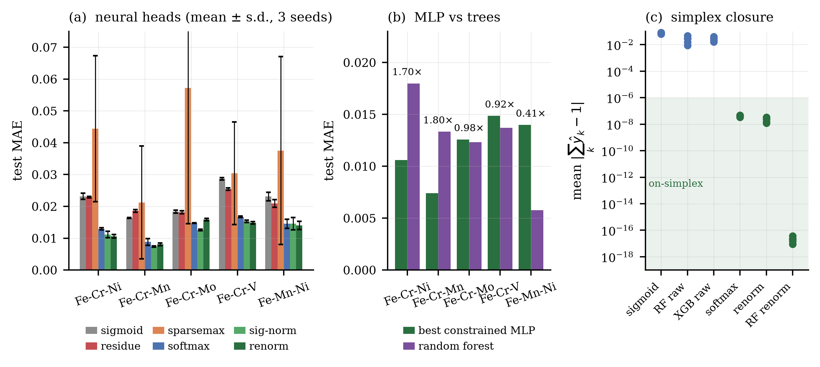
Figure 3. Comparative regression accuracy and constraint adherence. (a) Mean test MAE for the evaluated neural network heads. (b) Relative MAE performance ratio of the best constrained MLP against the random forest baseline. (c) Quantification of simplex closure violations, demonstrating that structurally constrained heads and renormalized baselines satisfy mass-balance within machine precision bounds.

Mass-Balance Simplex Closure
Enforcing the physical mass-balance requirement is critical for the admissibility of surrogate outputs in subsequent thermodynamic calculations. As detailed in Table 5, all structurally constrained neural network heads satisfied the closure equality constraint ($\sum_{k}{{\overset{ˆ}{y}}_{k}}=1$) to within 32-bit floating-point precision ($≤5×{10}^{-8}$). In stark contrast, unconstrained sigmoid outputs violated this fundamental closure requirement by an average of 6% to 8%, and raw tree-based outputs exhibited violations between 0.9% and 4.7%. While post-hoc renormalization successfully repaired baseline outputs to machine precision ($∼{10}^{-17}$), the structurally constrained MLPs achieved this physically admissible state natively without requiring secondary projection steps.
Table 5. Mean closure violations ($|\sum_{k}{{\overset{ˆ}{y}}_{k}}-1|$) on the test partition. Structurally constrained architectures achieve closure at float32 precision, while unconstrained models exhibit unphysical deviations spanning orders of magnitude.
Closure | Model | Fe–Cr–Ni | Fe–Cr–Mn | Fe–Cr–Mo | Fe–Cr–V | Fe–Mn–Ni
none | sigmoid | 6.2×10⁻² | 8.1×10⁻² | 8.1×10⁻² | 6.3×10⁻² | 7.4×10⁻²
none | random forest, raw | 2.8×10⁻² | 2.9×10⁻² | 4.7×10⁻² | 1.5×10⁻² | 8.7×10⁻³
none | XGBoost, raw | 2.8×10⁻² | 3.3×10⁻² | 4.1×10⁻² | 2.1×10⁻² | 1.6×10⁻²
structural | softmax | 3.3×10⁻⁸ | 4.8×10⁻⁸ | 4.4×10⁻⁸ | 3.4×10⁻⁸ | 4.5×10⁻⁸
structural | sigmoid/Σ | 1.7×10⁻⁸ | 2.7×10⁻⁸ | 3.3×10⁻⁸ | 1.6×10⁻⁸ | 3.1×10⁻⁸
structural | sparsemax | 1.7×10⁻⁸ | 1.8×10⁻⁸ | 5.0×10⁻⁸ | 1.0×10⁻⁸ | 4.0×10⁻¹⁰
structural | residue | 9.2×10⁻⁹ | 1.9×10⁻⁸ | 1.8×10⁻⁸ | 6.5×10⁻⁹ | 1.8×10⁻⁸
post hoc | sigmoid + renorm | 1.5×10⁻⁸ | 2.5×10⁻⁸ | 2.5×10⁻⁸ | 1.2×10⁻⁸ | 3.3×10⁻⁸
post hoc | random forest + renorm | 2.3×10⁻¹⁷ | 2.0×10⁻¹⁷ | 3.8×10⁻¹⁷ | 1.5×10⁻¹⁷ | 8.9×10⁻¹⁸

The Regressor–Detector Gap
A critical distinction emerged between continuous regression accuracy (MAE) and discrete phase-presence detection (quantified via F₁ scores and balanced accuracy). As summarized in Table 6 and Figure 4, the model minimizing aggregate MAE is not necessarily the optimal phase-presence detector. This discrepancy is largely attributed to the sparsity of rare phases: zero-fraction rows dominate the global loss calculation, meaning a model can achieve a low aggregate MAE while entirely failing to resolve a trace phase. For example, in the Fe–Mn–Ni system, the MLP failed to detect three rare phases (F₁ = 0), whereas the random forest successfully resolved two of them.
This regressor–detector gap proved robust across varying classification thresholds. Sensitivity analyses evaluating phase presence thresholds of 10⁻⁴, 10⁻³, and 10⁻² (Table 7) confirmed that while absolute F₁ scores shifted as expected, the relative rank order of model detection capability remained highly stable across four of the five systems. Crucially, phase-presence detection was observed to be highly sensitive to distribution shifts; on the held-out temperature band of the Fe–Cr–Ni system, the MLP's mean F₁ score degraded from 0.93 to 0.64, even as continuous MAE remained relatively stable.
Table 6. Quantitative comparison of continuous regression performance (MAE) versus discrete phase-presence detection (F₁ score and balanced accuracy). The data highlight that optimal regression performance does not inherently guarantee optimal phase detection.
System | Model | MAE | F₁ | Bal. acc. | Entropy-w. MAE
Fe–Cr–Ni | MLP renorm | 0.0106 | 0.927 | 0.939 | 0.0137
 | random forest | 0.0180 | 0.846 | 0.887 | 0.0218
Fe–Cr–Mn | MLP sig-norm | 0.0074 | 0.527 | 0.752 | 0.0089
 | random forest | 0.0133 | 0.592 | 0.850 | 0.0150
Fe–Cr–Mo | MLP sig-norm | 0.0126 | 0.643 | 0.827 | 0.0149
 | random forest | 0.0123 | 0.629 | 0.858 | 0.0147
Fe–Cr–V | MLP renorm | 0.0149 | 0.718 | 0.822 | 0.0167
 | random forest | 0.0137 | 0.785 | 0.893 | 0.0158
Fe–Mn–Ni | MLP renorm | 0.0140 | 0.312 | 0.643 | 0.0158
 | random forest | 0.0058 | 0.504 | 0.884 | 0.0063

Table 7. Sensitivity analysis of phase-presence detection metrics as a function of the minimum fractional presence threshold, confirming the stability of the observed regressor–detector gap.
System | Model | F₁ at 10⁻⁴ | F₁ at 10⁻³ | F₁ at 10⁻²
Fe–Cr–Ni | best MLP (renorm) | 0.870 (6) | 0.927 (4) | 0.962 (3)
 | random forest | 0.815 (6) | 0.846 (6) | 0.911 (2)
Fe–Cr–Mn | best MLP (sig-norm) | 0.489 (6) | 0.527 (2) | 0.550 (2)
 | random forest | 0.571 (20) | 0.592 (18) | 0.672 (19)
Fe–Cr–Mo | best MLP (sig-norm) | 0.562 (13) | 0.643 (2) | 0.710 (3)
 | random forest | 0.590 (2) | 0.629 (3) | 0.727 (4)
Fe–Cr–V | best MLP (renorm) | 0.671 (35) | 0.718 (1) | 0.731 (1)
 | random forest | 0.767 (6) | 0.785 (9) | 0.870 (6)
Fe–Mn–Ni | best MLP (renorm) | 0.306 (5) | 0.312 (4) | 0.314 (4)
 | random forest | 0.470 (0) | 0.504 (1) | 0.603 (21)

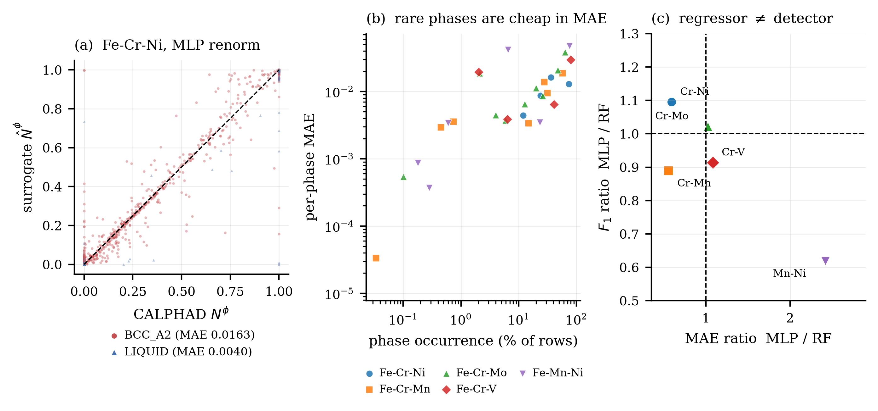
Figure 4. Analysis of the regressor–detector gap. (a) Parity plot contrasting the predictive accuracy of the most frequent versus least frequent phases in the Fe–Cr–Ni system. (b) Correlation between per-phase MAE and overall phase occurrence frequency. (c) Ratio comparison of MAE against F₁ score, illustrating domains where optimal regressors act as inferior detectors.

Closing the Detector Gap with a Presence-Gated Head
Separating the presence decision from the fraction estimate closes most of the gap at no regression cost on the ternaries (Table 9, Figure 6). Across the five ternaries, the bare renorm MLP macro area under the precision–recall curve (macro-AUPRC) spans 0.36–0.99 and the gated head 0.91–0.99. The gated head beats the best classical detector on four of the five systems (Fe–Cr–V is a 0.988 against 0.990 near-tie) Test MAE falls on all five systems, by 6% on Fe–Cr–Ni and 72% on Fe–Mn–Ni (0.0140 to 0.0039). Per-phase scores locate the effect: on Fe–Cr–Mn, ALPHA_MN rises from 0.004 to 0.933 and BETA_MN from 0.005 to 0.896; on Fe–Mn–Ni, MNNI rises from 0.003 to 1.00. One rare phase resists: the 0.1%-occurrence MU_PHASE_I in Fe–Cr–Mo stays below 0.5. The weighted-only ablation is insufficient (0.51–0.99, and it degrades MAE by 28% on Fe–Cr–V). Presence supervision, not loss reweighting, is the operative ingredient.
The remedy transfers without retuning. On quaternary Fe–Cr–Ni–C, the gated head raises macro-AUPRC from 0.805 to 0.965 (CEMENTITE from 0.09 to 0.873, GRAPHITE from 0.58 to 0.926) at a 12% MAE cost. On Fe–Cr–C, it rises from 0.559 to 0.922 at a 47% cost. On the Fe-free systems, detection comes nearly for free. Cr–Co–Ni rises from 0.799 to 0.979 (HCP_A3, invisible to the joint head at 0.02, reaches 0.91) while MAE improves from 0.0055 to 0.0045. Cr–Ni–Mn rises from 0.877 to 0.971 with MAE improving from 0.0040 to 0.0036.
Under shift, the remedy holds except where detection itself collapses. On contiguous bands, the gated head matches or beats the fraction-only MLP while outperforming the forest by a wide margin, with macro-AUPRC at 0.96–1.00. Under composition extrapolation, it wins on Fe–Cr–Ni (0.147 against 0.172) but loses on Fe–Cr–V, where the presence head misfires out of distribution. Under temperature extrapolation, all families fail together and gated AUPRC collapses to 0.59–0.63. Two caveats apply: the remedy was designed after the bare regressor failed on these test sets, so its numbers are post-hoc; and the shift evaluation covers two systems only.
Table 8. Presence-gated remedy. Macro-AUPRC (mean over three seeds; zero-positive phases excluded) for the renorm MLP, the three tree/k-NN baselines, the phase-weighted ablation, and the gated two-stage head; the final column is the gated-head test MAE relative to the renorm MLP (below 1 means the gated head also improves regression). Best AUPRC per row in bold.
 | macro-AUPRC (3 seeds) |  |  |  |  |  | gated/MLP MAE ratio
System | MLP renorm | RF | XGBoost | k-NN | weighted | gated | MAE ratio
Fe–Cr–Ni | 0.991 | 0.989 | 0.989 | 0.981 | 0.990 | 0.994 | 0.94
Fe–Cr–Mn | 0.567 | 0.798 | 0.801 | 0.959 | 0.820 | 0.970 | 0.93
Fe–Cr–Mo | 0.728 | 0.868 | 0.886 | 0.878 | 0.756 | 0.905 | 0.69
Fe–Cr–V | 0.741 | 0.990 | 0.990 | 0.983 | 0.951 | 0.988 | 0.74
Fe–Mn–Ni | 0.361 | 0.837 | 0.851 | 0.931 | 0.509 | 0.972 | 0.28
Fe–Cr–Ni–C | 0.805 | 0.860 | 0.854 | 0.846 | 0.838 | 0.965 | 1.12
Fe–Cr–C | 0.559 | 0.896 | 0.897 | 0.897 | 0.804 | 0.922 | 1.47
Ratio >1: the gated head costs MAE relative to MLP renorm.
Deployment needs to know when not to trust the surrogate. Two per-row scores were evaluated on the five ternary systems using artifacts the protocol already produces. The first is ensemble disagreement (U1): the per-row standard deviation across the three seed models, averaged over phases. The second is input-space distance (U2): the distance to the nearest training row in standardized coordinates. U1 carries real signal. Its Spearman correlation with per-row error averages 0.707 (0.94 on Fe–Cr–Ni, 0.93 on Fe–Cr–Mn, 0.87 on Fe–Cr–V, 0.69 on Fe–Cr–Mo, but 0.11 on Fe–Mn–Ni). Retaining the 50% lowest-U1 rows cuts MAE from 0.0123 to 0.0029 on Fe–Cr–Ni (a factor of 4.3), with similar factors on Fe–Cr–Mn and Fe–Cr–Mo. On Fe–Cr–V and Fe–Mn–Ni the curve is flat or reversed, so the gate must be validated once per system before use. Ensemble averaging itself is only a small refinement (mean gain 0.35% on fully paired rows).
Input-space distance has no power (mean area under the receiver-operating characteristic curve (AUROC) 0.408, below random). Under interpolation every test row is close to training rows, while the hardest rows sit near phase boundaries. Disagreement cannot replace the spatial protocols either: models trained on the same data can agree confidently and wrongly where training carries no information. The division of labor is therefore fixed: U1 for cheap per-row triage inside the trained region, holdout protocols or direct CALPHAD revalidation anywhere else.

Uncertainty Triage with Ensemble Disagreement

Spatial Generalization and Extrapolation Limits
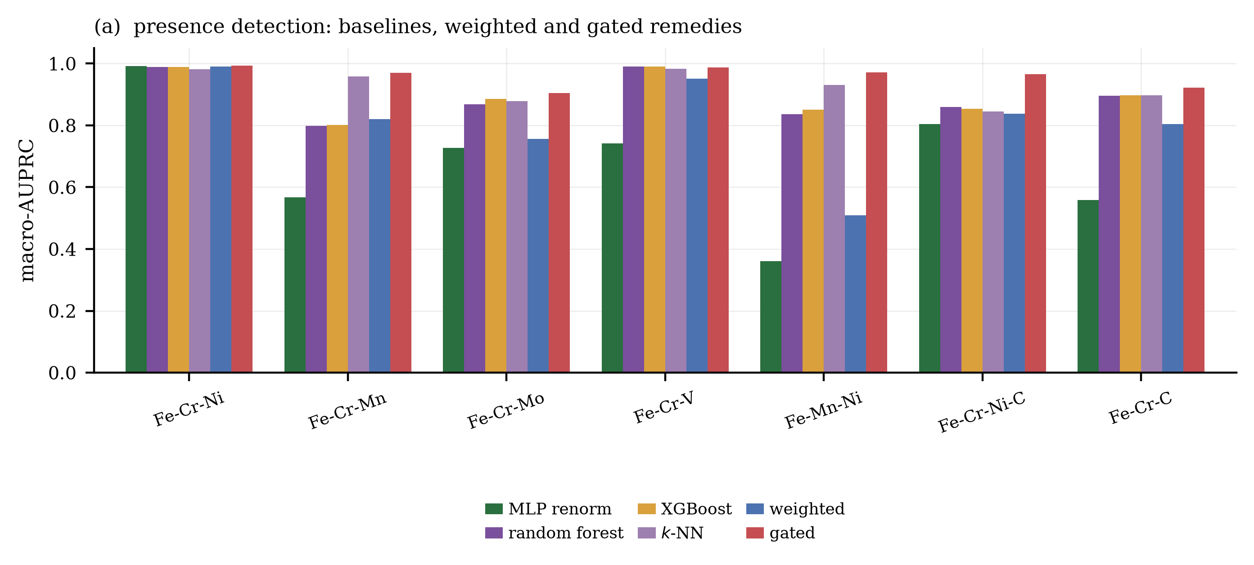
Figure 5. Macro-AUPRC by system and family (mean over three seeds). The gated two-stage head (rightmost bar in each group) matches or exceeds the best classical detector on six of the seven tabulated systems and lifts the constrained MLP far above its bare regression ranking on the rare-phase systems.
The models were subjected to rigorous spatial generalization tests utilizing strictly sized-matched random controls to decouple spatial degradation from training data attrition.
Contiguous Interior-Band Holdout: Results for the missing-region generalization test (Table 9, Figure 6a) demonstrated that degradation on the held-out temperature band was largely attributable to the reduced data volume; both the MLP and the random forest paid an equivalent 1.31× penalty ratio relative to their matched controls on the Fe–Cr–Ni system. However, performance separated significantly on the composition holdout band, which spanned steep phase boundaries. Across systems containing contiguous compositional holdouts, constrained MLPs degraded more gracefully than tree-based models, yielding a consistently lower penalty ratio (e.g., 1.61× versus 3.11× for the random forest on Fe–Cr–Ni).
Strict One-Sided Extrapolation: As detailed in Table 10 and Figure 7, true out-of-range extrapolation yielded severe degradation across all evaluated model families. For compositional extrapolation in the Fe–Cr–Ni system, MAE deteriorated by an order of magnitude, rising to ~0.17 for the constrained MLP and ~0.22 for the random forest, relative to ~0.012 on the matched interpolation controls. While the constrained MLP consistently achieved the lowest absolute far-side error across all five systems in both composition and temperature extrapolation, the overarching result underscores that no current architecture extrapolated phase fractions reliably beyond the explicit limits of the training domain.
Table 9. Predictive degradation under contiguous interior-band holdouts. Penalty ratios strictly compare the holdout error against a size-matched random control, isolating the spatial penalty from data-volume effects.
Held-out region | Model | Fe–Cr–Ni | Fe–Cr–Mn | Fe–Cr–Mo | Fe–Cr–V | Fe–Mn–Ni
random control | MLP renorm | 0.0101 (8) | 0.0083 (6) | 0.0153 (5) | 0.0234 (70) | 0.0122 (2)
random control | MLP sigmoid/Σ | 0.0107 (10) | 0.0077 (6) | 0.0125 (7) | 0.0146 (13) | 0.0123 (1)
random control | random forest | 0.0198 (11) | 0.0142 (5) | 0.0140 (11) | 0.0155 (12) | 0.0058 (4)
random control | XGBoost | 0.0237 (9) | 0.0167 (6) | 0.0152 (11) | 0.0194 (7) | 0.0084 (1)
T ∈ [1200, 1400] K | MLP renorm | 0.0132 (9) | 0.0079 (4) | 0.0266 (4) | 0.0358 (3) | 0.0022 (0)
T ∈ [1200, 1400] K | MLP sigmoid/Σ | 0.0144 (32) | 0.0077 (0) | 0.0265 (4) | 0.0372 (12) | 0.0024 (2)
T ∈ [1200, 1400] K | random forest | 0.0258 (10) | 0.0123 (2) | 0.0309 (12) | 0.0762 (97) | 0.0090 (6)
T ∈ [1200, 1400] K | XGBoost | 0.0408 (17) | 0.0203 (16) | 0.0348 (17) | 0.0823 (77) | 0.0167 (7)
x₂ ∈ [0.25, 0.35] | MLP renorm | 0.0162 (7) | 0.0071 (0) | 0.0155 (5) | 0.0111 (52) | 0.0005 (0)
x₂ ∈ [0.25, 0.35] | MLP sigmoid/Σ | 0.0163 (6) | 0.0071 (3) | 0.0144 (7) | 0.0075 (15) | 0.0010 (5)
x₂ ∈ [0.25, 0.35] | random forest | 0.0615 (73) | 0.0223 (6) | 0.0259 (9) | 0.0288 (5) | 0.0043 (1)
x₂ ∈ [0.25, 0.35] | XGBoost | 0.0530 (22) | 0.0250 (11) | 0.0324 (3) | 0.0368 (27) | 0.0063 (7)
penalty T / x₂ | MLP renorm | 1.31 / 1.61 | 0.95 / 0.85 | 1.74 / 1.01 | 1.53 / 0.48 | 0.18 / 0.04
penalty T / x₂ | MLP sigmoid/Σ | 1.34 / 1.52 | 1.00 / 0.92 | 2.12 / 1.16 | 2.55 / 0.52 | 0.20 / 0.08
penalty T / x₂ | random forest | 1.31 / 3.11 | 0.86 / 1.57 | 2.21 / 1.85 | 4.92 / 1.86 | 1.54 / 0.73
penalty T / x₂ | XGBoost | 1.72 / 2.24 | 1.21 / 1.49 | 2.29 / 2.13 | 4.24 / 1.89 | 2.00 / 0.75

Table 10. Absolute MAE and penalty ratios for strict one-sided extrapolation beyond the established bounds of the training coordinates. All models exhibit sharp error increases under genuine extrapolation.
Region | Model | Fe–Cr–Ni | Fe–Cr–Mn | Fe–Cr–Mo | Fe–Cr–V | Fe–Mn–Ni
random control (x₂-matched) | MLP renorm | 0.0123 (3) | 0.0094 (2) | 0.0181 (5) | 0.0242 (73) | 0.0135 (6)
random control (x₂-matched) | MLP sigmoid/Σ | 0.0128 (16) | 0.0092 (3) | 0.0144 (5) | 0.0163 (13) | 0.0146 (10)
random control (x₂-matched) | random forest | 0.0236 (7) | 0.0168 (1) | 0.0167 (6) | 0.0191 (11) | 0.0084 (2)
random control (x₂-matched) | XGBoost | 0.0283 (14) | 0.0202 (7) | 0.0184 (5) | 0.0235 (16) | 0.0118 (2)
train x₂ ≤ 0.25, test x₂ > 0.35 | MLP renorm | 0.1721 (77) | 0.0458 (17) | 0.0668 (26) | 0.0464 (66) | 0.0143 (25)
train x₂ ≤ 0.25, test x₂ > 0.35 | MLP sigmoid/Σ | 0.1709 (65) | 0.0526 (28) | 0.0689 (8) | 0.0478 (60) | 0.0129 (8)
train x₂ ≤ 0.25, test x₂ > 0.35 | random forest | 0.2152 (9) | 0.0788 (5) | 0.1052 (22) | 0.0761 (50) | 0.0279 (6)
train x₂ ≤ 0.25, test x₂ > 0.35 | XGBoost | 0.2267 (28) | 0.0860 (47) | 0.1082 (12) | 0.1015 (38) | 0.0329 (3)
random control (T-matched) | MLP renorm | 0.0127 (2) | 0.0100 (2) | 0.0187 (8) | 0.0277 (4) | 0.0142 (5)
random control (T-matched) | MLP sigmoid/Σ | 0.0142 (12) | 0.0102 (3) | 0.0153 (4) | 0.0158 (8) | 0.0151 (4)
random control (T-matched) | random forest | 0.0245 (10) | 0.0178 (5) | 0.0173 (6) | 0.0194 (17) | 0.0080 (3)
random control (T-matched) | XGBoost | 0.0285 (14) | 0.0214 (3) | 0.0191 (5) | 0.0243 (18) | 0.0111 (1)
train T ≤ 1200 K, test T > 1400 K | MLP renorm | 0.2227 (66) | 0.1262 (41) | 0.0823 (27) | 0.0994 (6) | 0.1823 (0)
train T ≤ 1200 K, test T > 1400 K | MLP sigmoid/Σ | 0.2241 (96) | 0.1266 (48) | 0.0796 (19) | 0.0991 (11) | 0.1822 (0)
train T ≤ 1200 K, test T > 1400 K | random forest | 0.2346 (4) | 0.1524 (13) | 0.1073 (8) | 0.1937 (10) | 0.1834 (1)
train T ≤ 1200 K, test T > 1400 K | XGBoost | 0.2327 (6) | 0.1536 (16) | 0.1054 (5) | 0.1972 (20) | 0.1841 (2)
penalty x₂ / T | MLP renorm | 13.98 / 17.60 | 4.89 / 12.57 | 3.69 / 4.40 | 1.92 / 3.59 | 1.06 / 12.85
penalty x₂ / T | MLP sigmoid/Σ | 13.36 / 15.78 | 5.74 / 12.46 | 4.78 / 5.19 | 2.93 / 6.25 | 0.88 / 12.05
penalty x₂ / T | random forest | 9.12 / 9.56 | 4.69 / 8.55 | 6.29 / 6.21 | 3.99 / 9.97 | 3.30 / 22.84
penalty x₂ / T | XGBoost | 8.02 / 8.16 | 4.25 / 7.19 | 5.87 / 5.51 | 4.31 / 8.11 | 2.79 / 16.64

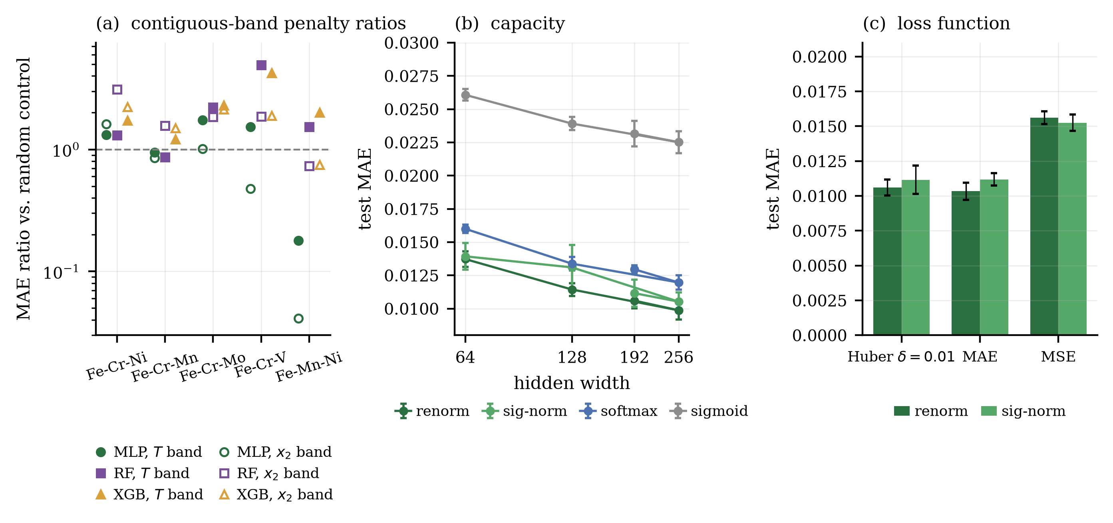
Figure 6. Generalization degradation analyses. (a) Penalty ratios corresponding to the contiguous interior-band holdouts. (b) Effect of neural network hidden-layer width on predictive accuracy. (c) Sensitivity of the renorm and sigmoid/Σ heads to the selection of the loss function.

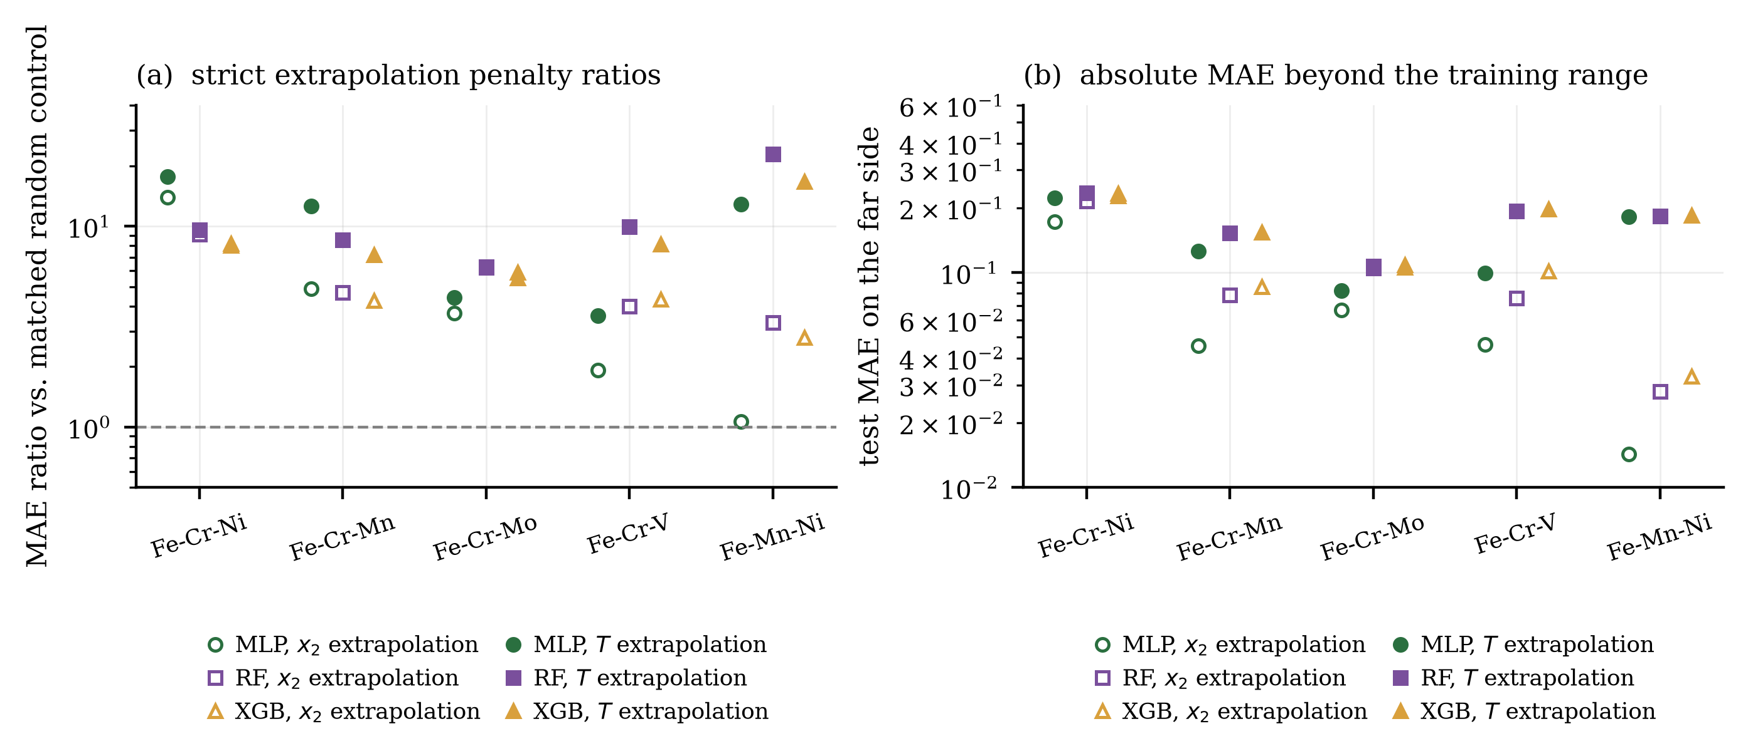
Figure 7. Strict one-sided extrapolation evaluation. (a) Penalty ratios for compositional and temperature extrapolation versus size-matched controls. (b) Absolute test MAE values on the extrapolated far side, highlighting the persistent challenge of out-of-support prediction.

Region-Matched Reanalysis and the Ideal-Form Control
Random controls remove different rows than the band, so penalty ratios conflate region difficulty with distribution shift. The region-matched reanalysis compares band-holdout error against the main-study models on the identical band rows (Table 8, panel A). Under this measure, the constrained MLP penalty is smaller than the tree ensembles’ in nine of the ten band–system combinations. On composition bands the ratios are 1.2–2.1 against 1.4–3.0 for the forest; on temperature bands 0.9–2.8 against 1.3–3.9, with Fe–Cr–Ni the single exception (2.8 against 2.1, although absolute holdout error remains twice the MLP’s at 0.0132 against 0.0258). One instability sits behind the headline: on Fe–Mn–Ni the MLP temperature ratios spread 0.9/20.3/0.6 across seeds from a near-zero denominator, downweighted in the ratio-of-means headline (1.1).
The ideal-form control (Table 8, panel B) confirms the penalty is spatial, not volumetric. At equal training size and on identical test rows, the training-size effect stays within 0.97–1.12 (mean 1.03) while removing the band still costs 0.93–3.84 (mean 2.01). The MLP degrades least in nine of ten combinations. Error therefore tracks data coverage, not data volume.
Table 11. Region-matched band reanalysis. Panel A: holdout mean MAE on band rows divided by in-distribution mean MAE on the identical rows (ratio of means; per-seed ratios in parentheses). Panel B repeats the comparison in ideal form — identical test rows and equal training size — reporting the band-in/band-out ratio H/I with the training-size effect I/main in parentheses.
Band | System | MLP renorm | random forest | XGBoost
(A) Region-matched ratios
x₂ band | Fe–Cr–Ni | 1.86 (1.96/1.80/1.82) | 3.01 (2.90/3.49/2.67) | 2.42 (2.21/2.78/2.33)
 | Fe–Cr–Mn | 1.46 (1.39/1.67/1.35) | 2.05 (1.97/2.39/1.86) | 1.92 (2.03/2.06/1.70)
 | Fe–Cr–Mo | 1.74 (1.79/1.71/1.72) | 2.18 (2.06/2.28/2.21) | 2.54 (2.40/2.52/2.71)
 | Fe–Cr–V | 2.06 (1.12/2.08/3.02) | 2.29 (2.46/2.50/1.97) | 2.32 (2.36/2.54/2.07)
 | Fe–Mn–Ni | 1.19 (1.00/1.58/1.11) | 1.44 (1.37/1.44/1.52) | 1.55 (1.20/1.80/1.74)
T band | Fe–Cr–Ni | 2.83 (2.66/2.93/2.87) | 2.14 (2.08/2.40/1.98) | 2.76 (2.59/3.15/2.62)
 | Fe–Cr–Mn | 1.18 (1.28/1.52/0.90) | 1.33 (1.36/1.28/1.34) | 1.64 (1.98/1.41/1.57)
 | Fe–Cr–Mo | 1.08 (1.03/1.03/1.20) | 1.94 (2.08/1.87/1.88) | 2.16 (2.44/2.24/1.85)
 | Fe–Cr–V | 0.91 (0.94/0.72/1.20) | 3.89 (3.78/4.01/3.86) | 3.23 (3.40/3.12/3.21)
 | Fe–Mn–Ni | 1.06 (0.86/20.28/0.62) | 2.63 (2.08/5.17/2.07) | 2.97 (2.81/3.52/2.67)
(B) Ideal-form control: H/I (I/main)
x₂ band | Fe–Cr–Ni | 1.78 (1.03) | 3.02 (1.01) | 2.46 (1.00)
 | Fe–Cr–Mn | 1.69 (1.02) | 2.04 (1.03) | 2.01 (1.01)
 | Fe–Cr–Mo | 1.88 (1.10) | 2.09 (1.03) | 2.46 (1.03)
 | Fe–Cr–V | 1.37 (1.10) | 2.06 (1.02) | 2.04 (1.04)
 | Fe–Mn–Ni | 1.21 (1.11) | 1.49 (1.03) | 1.51 (1.01)
T band | Fe–Cr–Ni | 2.35 (1.04) | 1.99 (1.02) | 2.47 (1.07)
 | Fe–Cr–Mn | 1.44 (1.01) | 1.53 (1.02) | 1.77 (1.03)
 | Fe–Cr–Mo | 1.14 (1.02) | 2.00 (1.02) | 2.12 (1.05)
 | Fe–Cr–V | 1.08 (1.00) | 3.84 (1.02) | 3.52 (0.97)
 | Fe–Mn–Ni | 0.93 (1.06) | 2.43 (0.98) | 2.48 (1.12)
Region-matched ratio of mean MAEs: holdout mean MAE on band rows divided by in-distribution mean MAE on the identical rows; per-seed ratios in parentheses (seeds 42/123/2024).
Ideal-form size-matched control (identical test rows, equal training size): band-in/band-out ratio H/I, training-size effect I/main in parentheses.

Model Ablations
To dissect the architectural dependencies of the neural network surrogates, a series of ablation studies were performed on the Fe–Cr–Ni system (Table 12, Figures 6b and 6c). The selection of loss function proved highly influential; mean squared error (MSE) exacerbated MAE by 47% relative to Huber () or standard MAE losses, primarily because trace phase outliers disproportionately skewed the squared gradient. Increasing hidden-layer capacity from 64 to 256 units monotonically improved accuracy, indicating that the default 192-unit architecture used across the benchmarking suite leaves further optimization headroom. Crucially, attempting to enforce mass balance via a soft sum-to-one loss penalty ( and ) degraded the overall fit by a factor of 8 to 16 without achieving the numerical strictness provided by structural output constraints.
Table 12. Architectural ablation study for the Fe–Cr–Ni system, evaluating the impacts of loss function formulation, network capacity, and soft closure penalties on the interpolation MAE.
Ablation | Setting | renorm | sigmoid/Σ
loss | Huber, δ = 0.01 (default) | 0.0106 (6) | 0.0112 (10)
loss | MAE | 0.0103 (6) | 0.0112 (4)
loss | MSE | 0.0156 (5) | 0.0152 (6)
width | 3×64 | 0.0137 (6) | 0.0139 (10)
width | 3×128 | 0.0114 (5) | 0.0131 (17)
width | 3×192 (default) | 0.0106 (6) | 0.0112 (10)
width | 3×256 | 0.0099 (7) | 0.0105 (7)
closure penalty | none | 0.0232 (10), closure 6.2×10⁻²
closure penalty | λ=1 | 0.0804 (51), closure 2.2×10⁻³
closure penalty | λ=10 | 0.1693 (228), closure 1.3×10⁻³

Evaluation of Failed Constraint Mechanisms (Negative Results)
Three theoretically plausible physical constraint mechanisms failed under the evaluated configurations (Figure 8), providing critical mechanistic insights into model formulation:
- Sparsemax: While successfully projecting logits to produce exact zeros, this operator exhibited severe seed sensitivity. The resulting inter-seed variance was on the same order of magnitude as the mean MAE, consistent with the hypothesis that gradients vanish identically once a logit drops below the threshold, trapping the network in poor initial local minima.
- Sum-to-One Penalty: As noted in the ablations, enforcing mass balance strictly as a regularizing loss term created pathological competition with the regression targets, buying partial closure entirely at the expense of model fit.
- Residue Closure: The algebraic deduction of the -th phase fraction () enforces sum-to-one closure by construction but does not intrinsically guarantee non-negativity: if the other predicted fractions sum to more than one, the residue is negative. In the stored predictions, the residue head emitted negative values on 0.0% (Fe–Cr–V), 0.02% (Fe–Mn–Ni), 0.40% (Fe–Cr–Ni), 0.50% (Fe–Cr–Mn), and 1.21% (Fe–Cr–Mo) of cells, with the most negative cell at −0.59. It is therefore closure-valid but not simplex-valid. It was also the least accurate constrained variant: even the best residue head was 1.3–2.5× worse than the best constrained head in the same system, and a sweep over all choices of the dropped phase (Figure 8c) shows the best choice is the dominant phase in four of five systems. The observed degradation is consistent with the residual phase absorbing the accumulated prediction error of the other K−1 channels; we note this as an interpretation supported by the sweep, not a directly demonstrated mechanism.

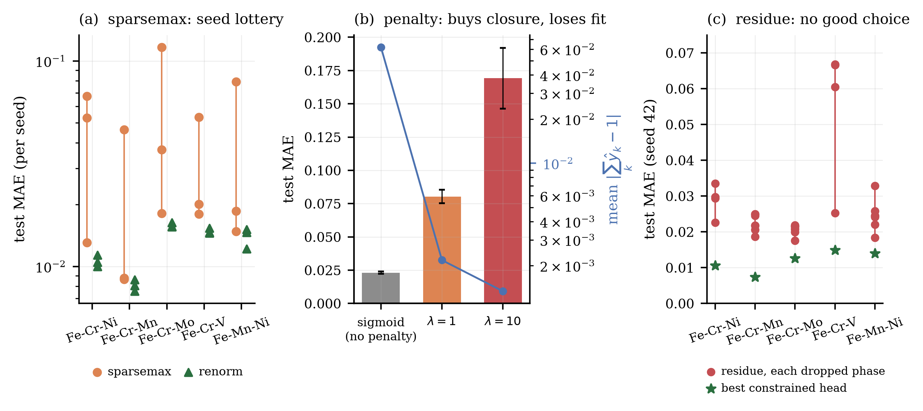
Figure 8. Diagnostic overview of failed constraint mechanisms. (a) Severe seed sensitivity and variance observed using the sparsemax operator. (b) The detrimental tradeoff between enforcing a soft closure penalty and maintaining regression accuracy. (c) Error accumulation in the residue closure head as a function of the chosen residual phase.

Phase Field Visualization and Error Concentration
Qualitative and quantitative assessments of the predicted phase fields (Figure 9) underscore the topological nature of the surrogate errors. Visual analysis of the Fe–Cr–Ni domain under the renorm head confirms that the neural surrogate faithfully reproduces the complex geometry of the underlying CALPHAD phase fields, accurately mapping the BCC, FCC, liquid, and sigma topologies.
However, mapping the spatial distribution of the absolute error reveals significant spatial concentration. By computing the parametric distance of each test row to the nearest shift in the active-phase set, it was determined that mean absolute errors in the closest spatial tertile to a phase boundary averaged 0.022, compared to 0.002 in the most distant interior tertile. This indicates that surrogate uncertainty is highly concentrated directly at structural phase boundaries, whereas the interior of single- or stable multi-phase fields is reproduced with an order of magnitude higher fidelity.
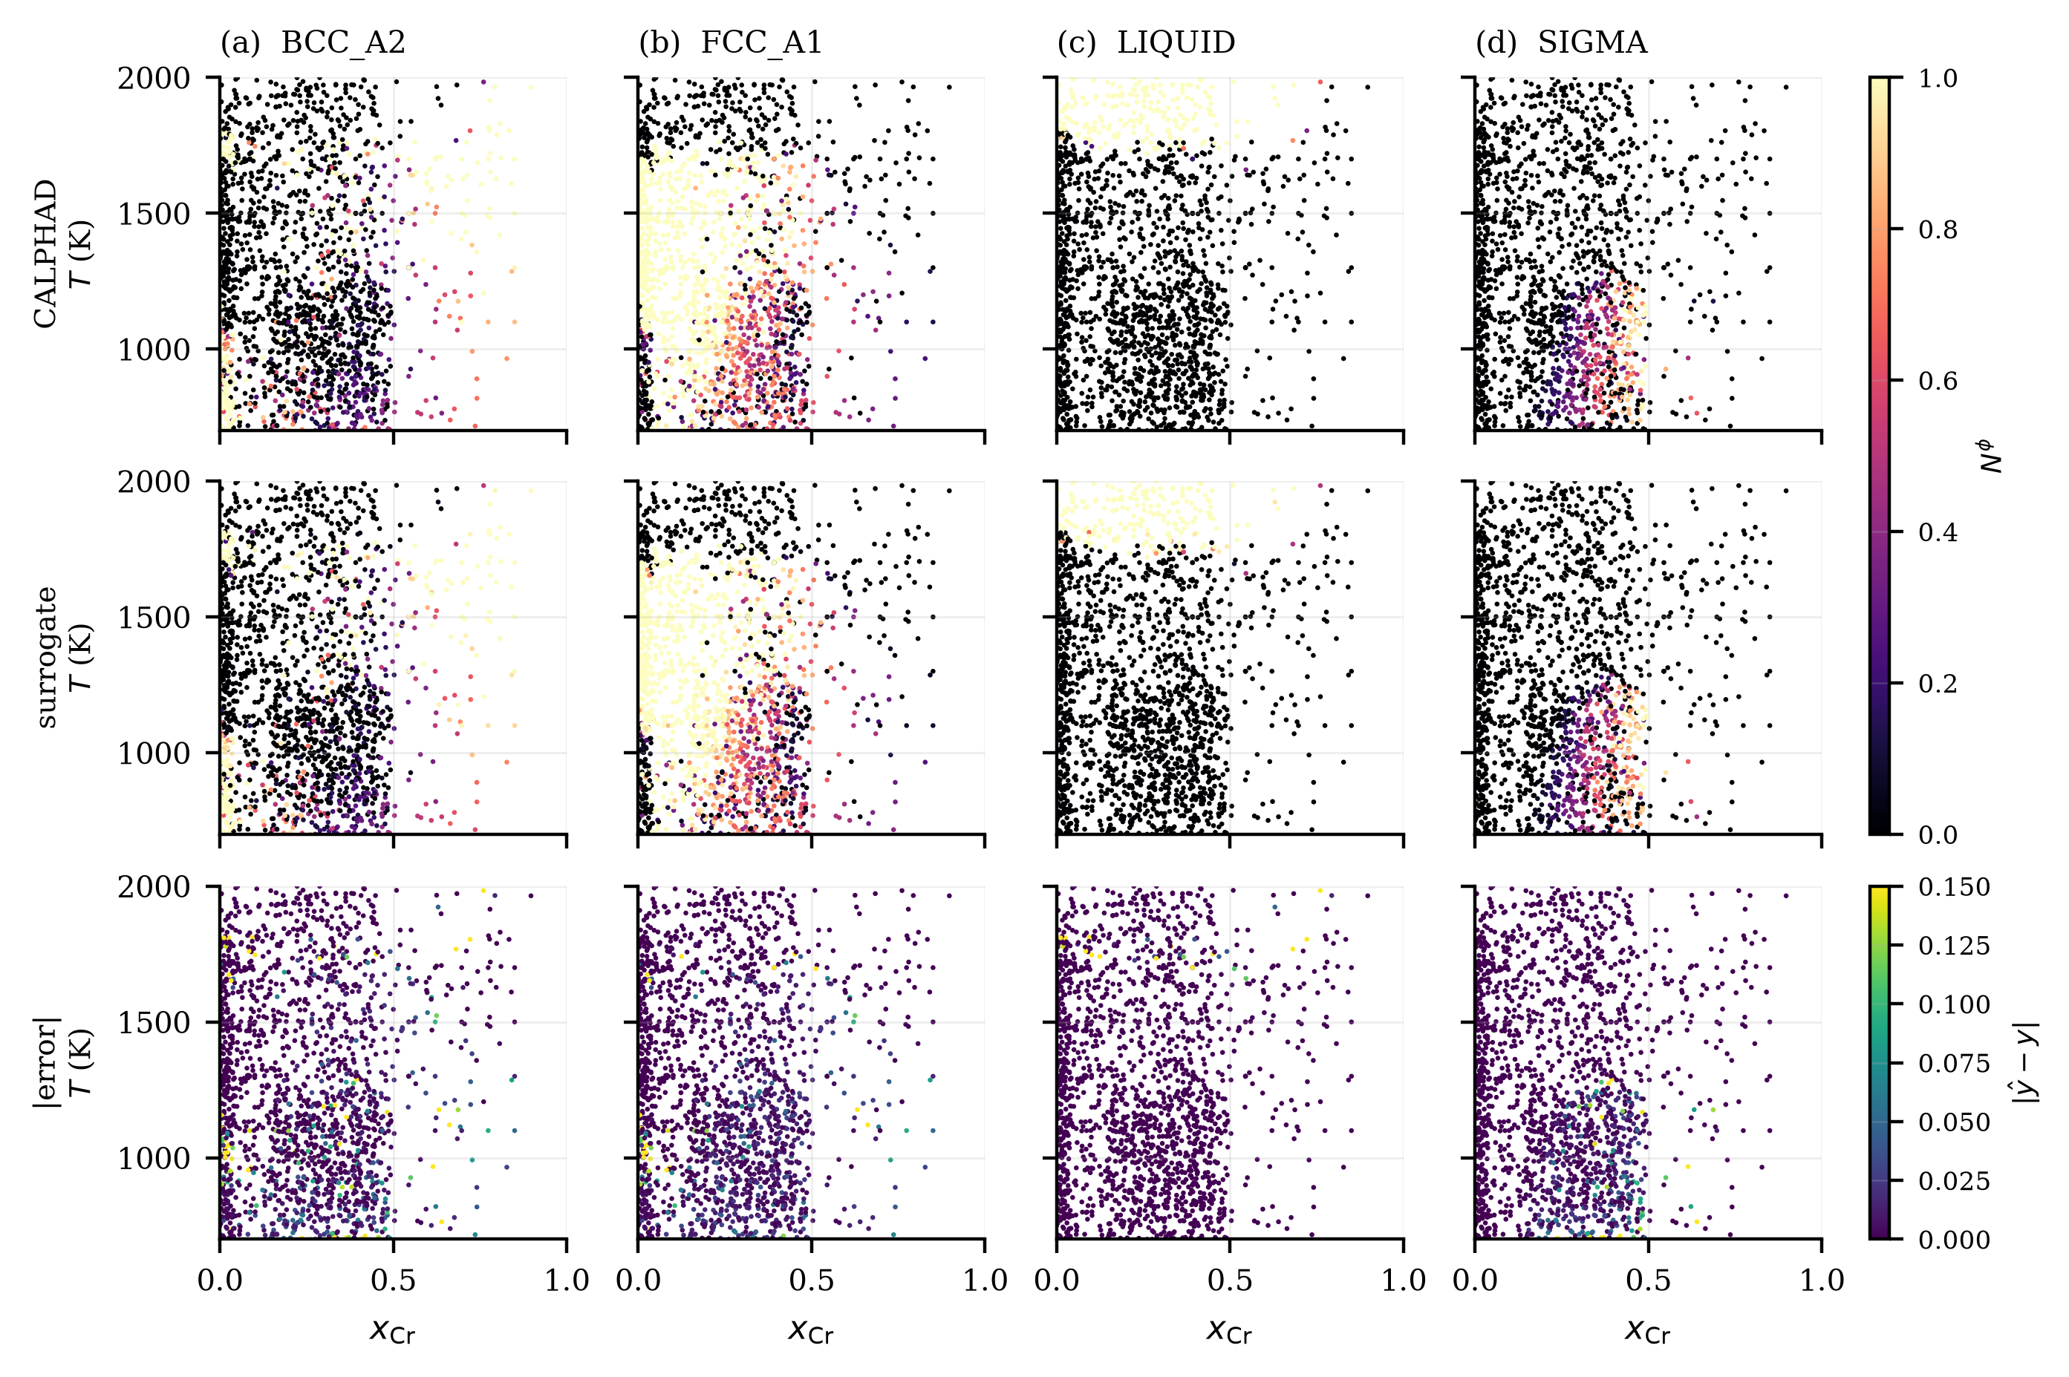
Figure 9. Ground-truth and predicted phase-fraction fields for the Fe–Cr–Ni system evaluated with the renorm head. The absolute error maps highlight the geometric concentration of predictive uncertainty at phase boundaries relative to the stable interiors of phase fields.

Extension to Quaternary, Carbide, and Fe-Free Systems
The full protocol re-run on the four extension systems shows the smooth-coexistence ranking survives four inputs (Table 13). On quaternary Fe–Cr–Ni–C, the renorm head reaches 0.0037 MAE against 0.0075 for the forest, a twofold margin larger than on any ternary. On Fe–Cr–C, sigmoid/Σ reaches 0.0029 against 0.0055. Beyond iron, renorm leads Cr–Co–Ni (0.0055 against 0.0070) and sigmoid/Σ leads nine-phase Cr–Ni–Mn (0.0036 against 0.0052). Sparsemax, which collapses on every Fe system, competes on dilute nine-phase targets (0.0048).
The detector gap widens exactly where phases get rarer, and the gated head transfers with no retuning. The quaternary bare MLP misses the rarer carbides and Fe–Cr–C collapses to 0.559 macro-AUPRC, while the gated head reaches 0.965 and 0.922. On the Fe-free systems the bare MLP misses HCP_A3 (0.02) and MNNI, and the gated head reaches 0.979 and 0.971 at best-or-tied MAE. The spatial protocols give the same qualitative answers: composition-band holdout costs about 2–3.5 times the control and strict extrapolation fails on every tested axis, worst in temperature (22–24 times on the transfer systems). The exception is Cr–Co–Ni bands, which test easier than the control (0.8 times, both bands FCC-dominated).
Table 13. Scope-extension systems. (A) System and dataset statistics. (B) Test MAE (mean over three seeds), best per system in bold. (C) Contiguous-band and strict-extrapolation holdouts against size-matched random controls. (D) Phase-set validation against the full eligible set.
(A) System and dataset statistics
System | Eligible | K | Rows | max|Σ y-1| | box (%) | T (K)
Fe–Cr–Ni–C | 35 | 9 | 13,192 | 8.2×10⁻⁹ | 69.9 | 700–2000
Fe–Cr–C | 32 | 9 | 13,199 | 6.8×10⁻⁹ | 100.0 | 700–2000
Cr–Co–Ni | 23 | 5 | 8,874 | 1.5×10⁻⁸ | 38.0 | 700–2000
Cr–Ni–Mn | 30 | 9 | 8,880 | 1.1×10⁻⁸ | 38.0 | 700–2000
(B) Test MAE, mean over 3 seeds
Model | Fe–Cr–Ni–C | Fe–Cr–C | Cr–Co–Ni | Cr–Ni–Mn
MLP heads
sigmoid | 0.0068 | 0.0070 | 0.0175 | 0.0107
softmax | 0.0054 | 0.0045 | 0.0062 | 0.0046
renorm | 0.0037 | 0.0032 | 0.0055 | 0.0040
sigmoid/Σ | 0.0042 | 0.0029 | 0.0065 | 0.0036
sparsemax | 0.0216 | 0.0153 | 0.0473 | 0.0048
residue | 0.0071 | 0.0095 | 0.0128 | 0.0108
baselines
random forest | 0.0075 | 0.0055 | 0.0070 | 0.0052
XGBoost | 0.0085 | 0.0074 | 0.0095 | 0.0067
k-NN | 0.0148 | 0.0100 | 0.0151 | 0.0071
ridge | 0.0810 | 0.0823 | 0.1073 | 0.0572
presence-supervised (see text)
gated | 0.0041 | 0.0047 | 0.0045 | 0.0036
(C) Spatial holdout and extrapolation
Protocol | Fe–Cr–Ni–C | Fe–Cr–C | Cr–Co–Ni | Cr–Ni–Mn
random control (band) | 0.0066 | 0.0050 | 0.0080 | 0.0052
T band | 0.0046 | 0.0058 | 0.0063 | 0.0114
x₂ band | 0.0234 | 0.0106 | 0.0060 | 0.0070
penalty T / x₂ | 0.70 / 3.55 | 1.16 / 2.12 | 0.78 / 0.74 | 2.18 / 1.34
random control (x₂) | 0.0063 | 0.0048 | 0.0096 | 0.0062
x₂ extrapolation | 0.0301 | 0.0130 | 0.0565 | 0.0560
random control (T) | 0.0075 | 0.0063 | 0.0086 | 0.0064
T extrapolation | 0.1144 | 0.1272 | 0.1917 | 0.1559
penalty x₂ / T | 4.81 / 15.21 | 2.74 / 20.09 | 5.86 / 22.21 | 9.03 / 24.30
random control (C) | — | 0.0050 | — | —
C extrapolation | — | 0.0130 | — | —
penalty C | — | 2.61 | — | —
(D) Phase-set validation
System | Points | OK | >10⁻³ | max|Δ NP| | max|Δ G| (J/mol)
Fe–Cr–Ni–C | 1500 | 1500 | 0 | 8.7×10⁻⁹ | 1.4×10⁻⁴
Fe–Cr–C | 1500 | 1497 | 9 | 0.95 | 35.7
Cr–Co–Ni | 1500 | 1500 | 0 | 6.1×10^-10 | 2.5×10^-5
Cr–Ni–Mn | 1500 | 1500 | 0 | 7.3×10^-10 | 1.9×10^-5

Experimental Anchor
Four published differential thermal analysis (DTA) transition temperatures bound the surrogate’s contribution against the database’s own disagreement with experiment (Figure 10). Three Fe–C–Cr alloy transitions come from Drozdov’a et al. [36] and one Fe–Cr–Ni liquidus from Yamada et al. [37]. At the 10⁻⁴ detection threshold the surrogate matches full CALPHAD within 21 K (mean 17.75 K), the same order as the database’s own mean deviation from experiment (19 K, median 8 K, driven by a single +59 K outlier). The surrogate term is larger on three of the four alloys. With n = 4, neither term can be declared limiting.
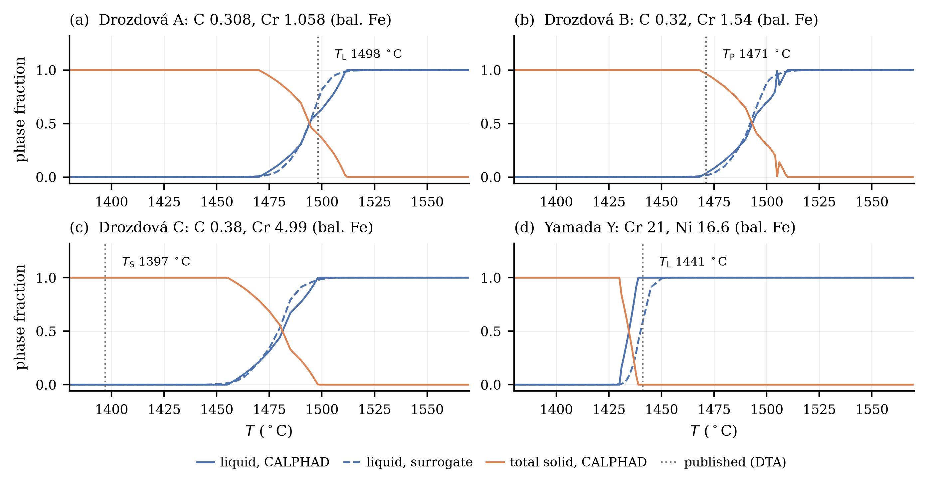
Figure 10. Experimental anchor: CALPHAD and surrogate liquid/solid fractions versus temperature for four alloys with published DTA transition temperatures (dotted markers). Three Fe–C–Cr alloys from Drozdov’a et al. [36] and one Fe–Cr–Ni alloy from Yamada et al. [37].

High-Throughput Screening
Fe–Cr–Ni was screened at T = 1000 K, below liquid appearance and at a service-relevant temperature, for a lean-nickel austenitic window: fully austenitic (FCC ≥ 0.99), sigma-free and melt-free (each ≤ 10⁻³), with nickel capped at 12 mol% (Table 14, Figure 12). The screen evaluated 501,501 compositions on a 10⁻³ simplex grid in 0.4 s, shortlisting 10,936 hits (2.18%). Every shortlisted alloy checked was confirmed: all 11 Pareto-frontier points (minimal Ni per Cr bin, falling from 7.5% Ni at 1.5% Cr to 4.8% near 12–13% Cr) under the full 28-phase set, all 400 points of a random hit subset, and the remaining 10,525 in a follow-up run with zero misses: 10,936 of 10,936. Treating the in-scope background miss rate (4 of 76) as representative, recall is ~0.8. The misses cluster at decision boundaries, and ensemble spread flags the worst one (Figure 11, panel a; AUROC 0.86; the clear failure carries ten times the shortlist 95th-percentile spread). The threshold sweep over the 811-point pool gives precision 1.00 at all nine FCC–sigma combinations (Figure 11, panel b; Table 14).
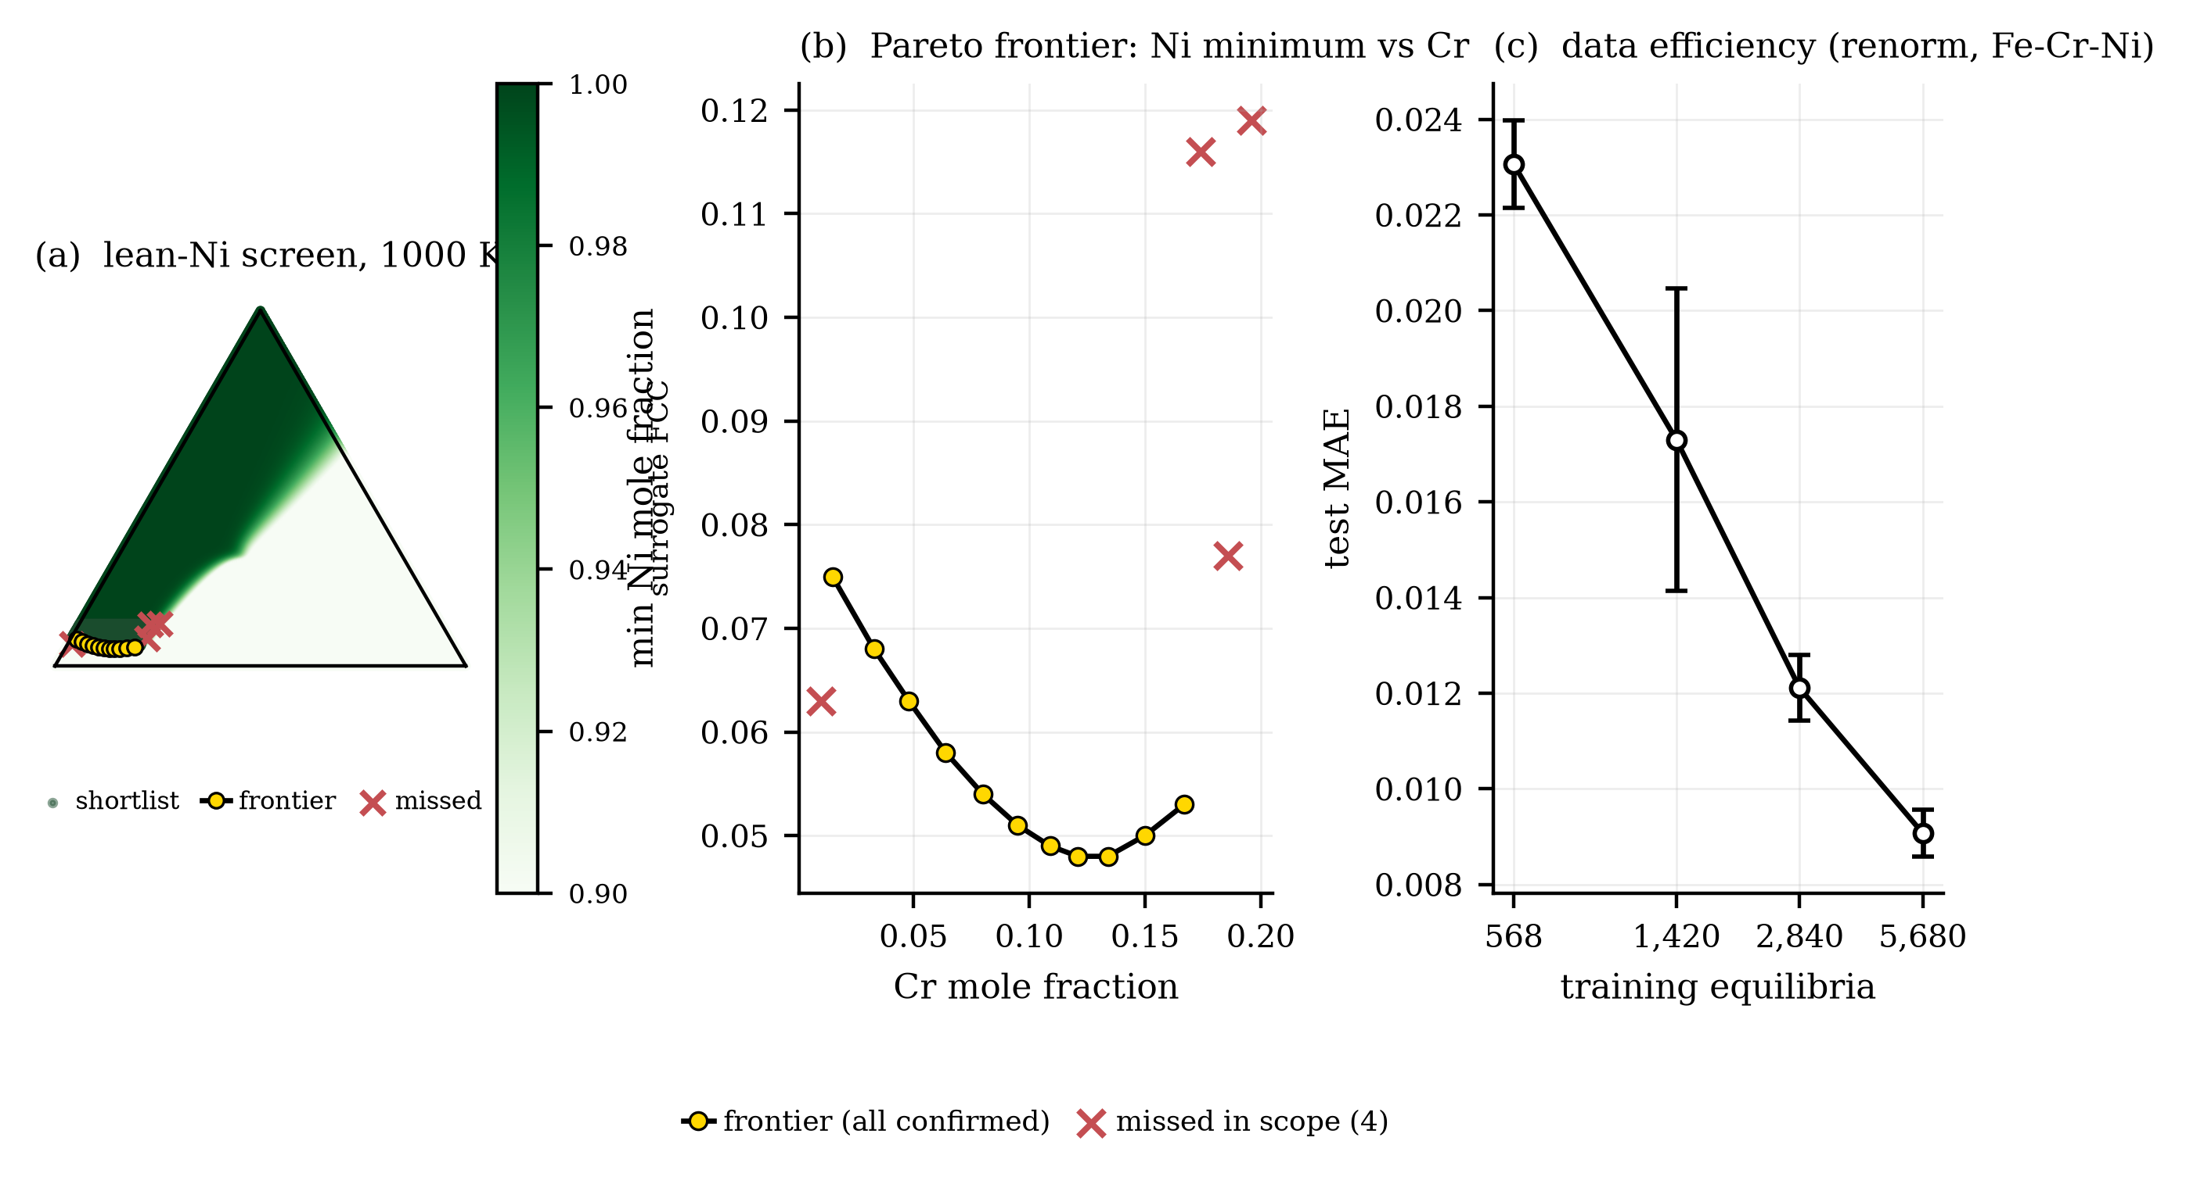
Figure 11. Lean-Ni austenitic screen at 1000 K. (a) Gibbs triangle coloured by surrogate FCC: shortlist, Pareto frontier of minimal Ni per Cr bin (all 11 full-CALPHAD-confirmed) and the four in-scope misses. (b) The frontier as minimal qualifying Ni versus Cr. (c) Data efficiency: test MAE versus training-set size.
One screen amortises the pipeline several times over. Against a measured 0.41 s per full-set solve and 268 s training, break-even is near 10⁴ points; the 501,501-point screen pays back roughly 7 to 50 times in a single query. Half the training data buys most of the accuracy (0.0121 at 50% against 0.0091 full). Commercial-grade projections show no grade-name bias: AISI 304 is correctly refused on its 3.7% CALPHAD sigma, and ferritic 430 is refused in agreement.
With carbon in the query the screen still works, and its failures mark the model’s edge (Table 15, Figure 13). On quaternary Fe–Cr–Ni–C, 330,000 compositions screen in 0.5 s with 14,475 hits (4.39%). The frontier reaches 2.9% Ni at near-zero Cr, with carbon substituting for both Ni and Cr. Of 20 frontier points 15 confirm; the 5 rejections form one contiguous Cr pocket where the screen over-smooths a two-phase region at its decision edge. Combined shortlist precision is 0.98 (14,143/14,475) at recall ~0.8. Disagreement gates transfer (AUROC 0.856), and break-even near 10⁴ points means the screen pays back roughly 10 to 30 times.
Table 14. Application case: lean-Ni austenitic screen at 1000 K on Fe–Cr–Ni. Break-even is the one-time cost divided by the measured 0.41 s per-point full-set saving.
Quantity | Value
Compositions screened | 501,501
Screen wall time, 3-seed ensemble (cuda) | 0.4 s
Query hits (FCC≥0.99, SIGMA≤10⁻³, LIQUID≤10⁻³, Ni≤0.12) | 10,936 (2.18%)
Pareto-frontier points (minimal Ni per Cr bin) | 11
Full-CALPHAD validated: frontier / hit subset / bg in scope | 11/11 / 400/400 / 4/76
Shortlist precision (10,936 validated shortlist points) | 1.00
In-scope recall estimate (Ni≤0.12, see text) | 0.8
Full-set CALPHAD cost per point, this workload (wall) | 0.41 s
Probe-set cost per point, this workload (wall) | 0.33 s
Break-even screen size (one-time per-point saving) | 10⁴ (optimistic) – 7×10⁴ (conservative; see text)
renorm test MAE at 10 / 25 / 50 / 100% of training data | 0.0231 / 0.0173 / 0.0121 / 0.0091
U1 gate at shortlist p99 | excludes 1 of 4 misses; retains 99.0% of shortlist
Threshold sweep, 9 combos (811-pt pool) | precision 1.00 everywhere; recall 0.80–1.00
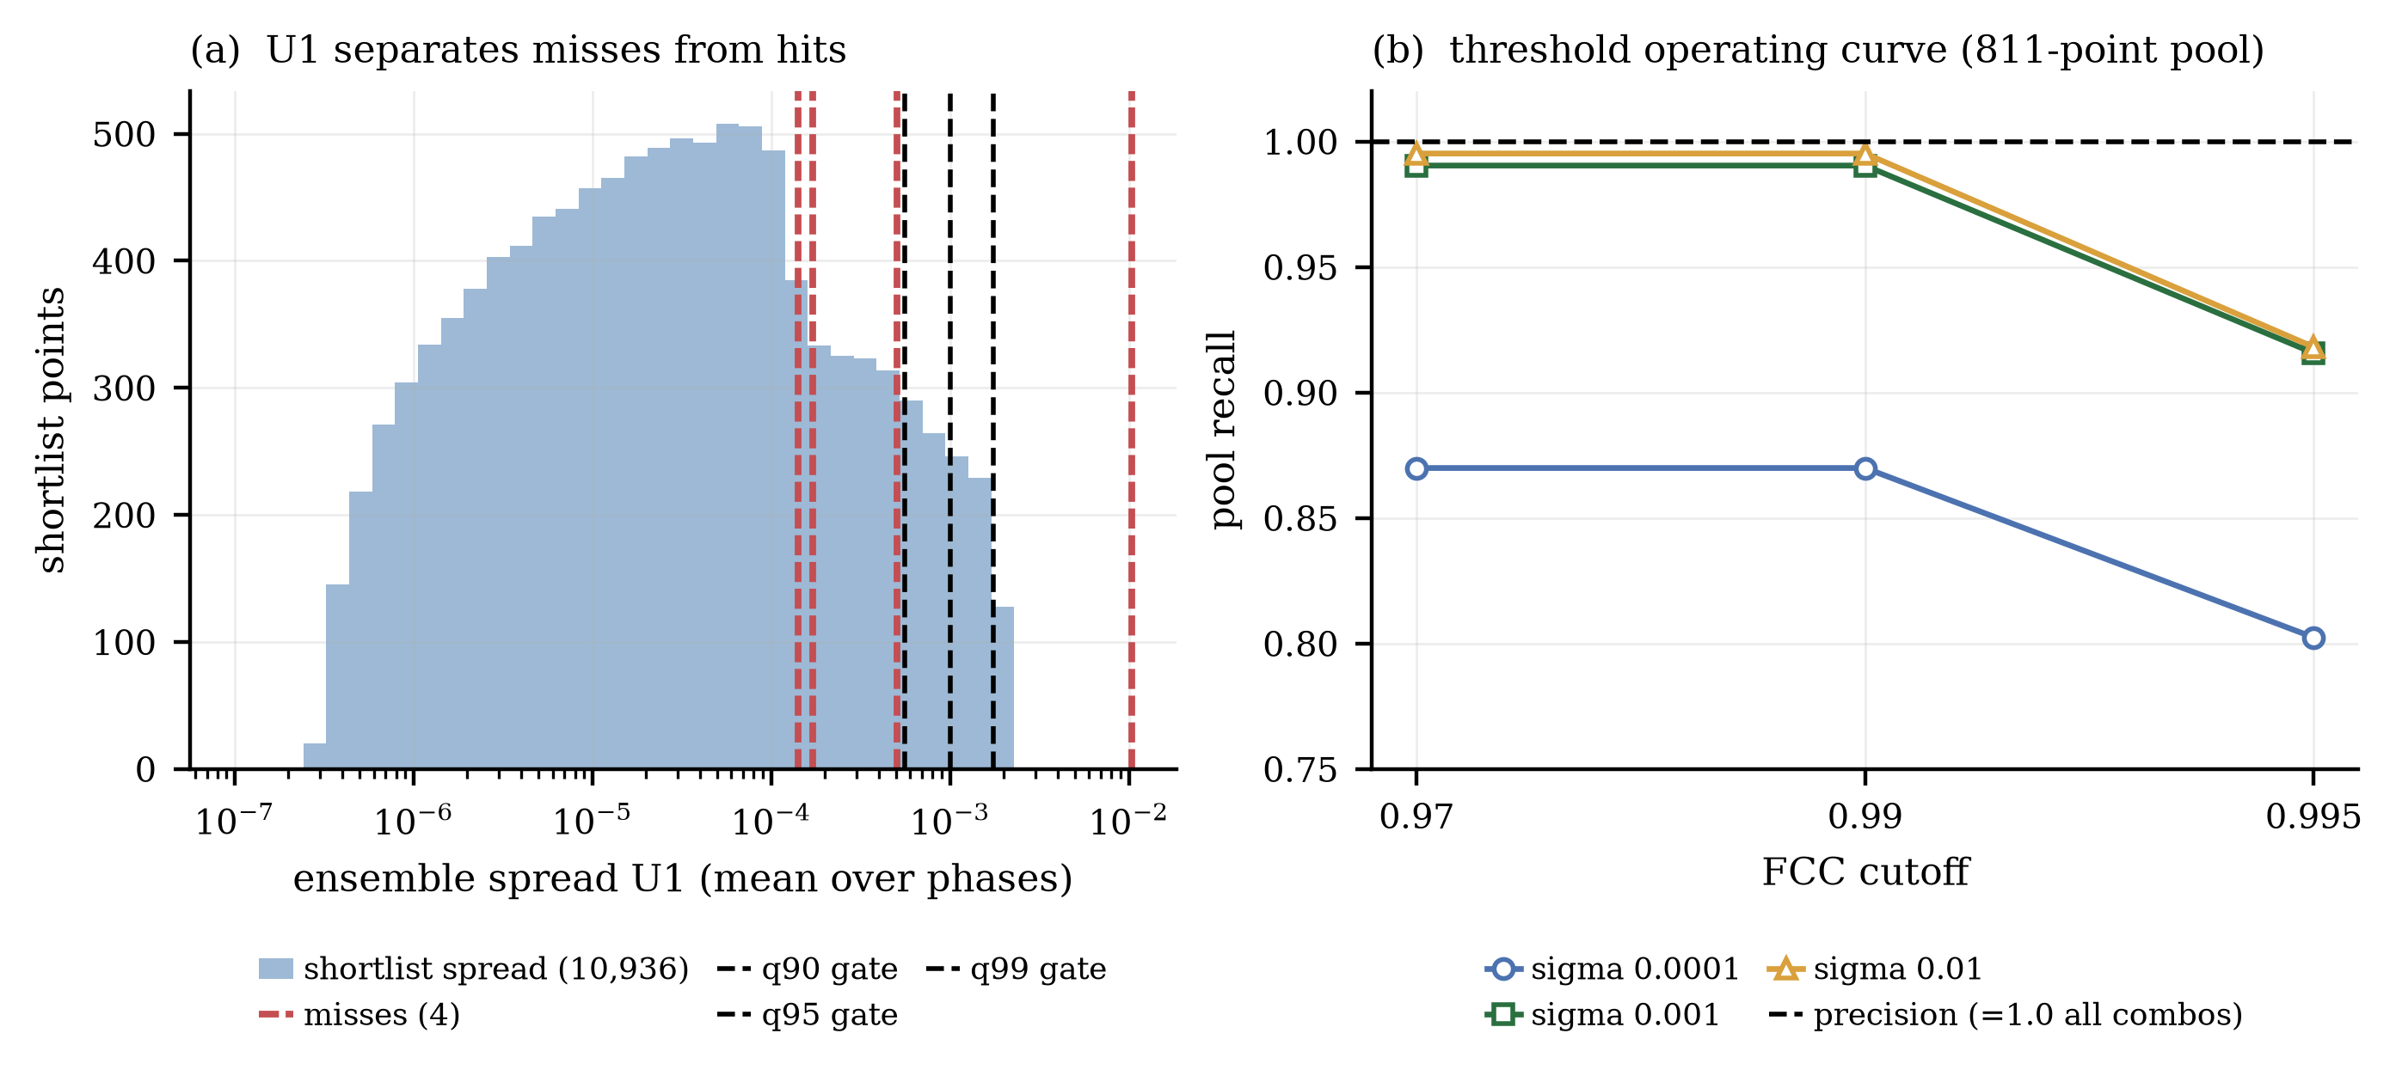
Figure 12. Screen operating characteristics. (a) Shortlist spread distribution (10,936 points) with the four in-scope misses and the 90/95/99th-percentile gates. (b) Pool precision and recall across the FCC–sigma threshold grid: precision is 1.00 at all nine combinations.
Table 15. Application case: quaternary lean-Ni screen with carbon at 1000 K on Fe–Cr–Ni–C.
Quantity | Value
Compositions screened (design box) | 330,000
Screen wall time, 3-seed ensemble (cuda) | 0.5 s
Query hits (FCC≥0.90, carbides≤0.05, SIGMA/LIQUID≤10⁻³, Ni≤0.12) | 14,475 (4.39%)
Pareto-frontier points (minimal Ni per Cr bin) | 20
Full-CALPHAD validated: frontier / hit subset / bg in scope | 15/20 / 392/400 / 5/131
Follow-up: remaining 14,055 shortlist points | 13,736/14,055 confirm (0.977); worst miss CAL FCC 0.731
Shortlist precision (14475 validated shortlist points) | 0.98
In-scope recall estimate (Ni≤0.12, see text) | 0.8
Full-set CALPHAD cost per point, this workload (wall) | 1.36 s
Probe-set cost per point, this workload (wall) | 0.94 s
Break-even screen size (one-time per-point saving) | 10⁴ (optimistic) – 3×10⁴ (conservative; see text)
U1 gate at shortlist p99 | excludes 1 of 5 misses; retains 99.0% of shortlist
Threshold sweep, 4 combos (820-pt pool) | precision 0.97–0.98; recall 0.92–0.99
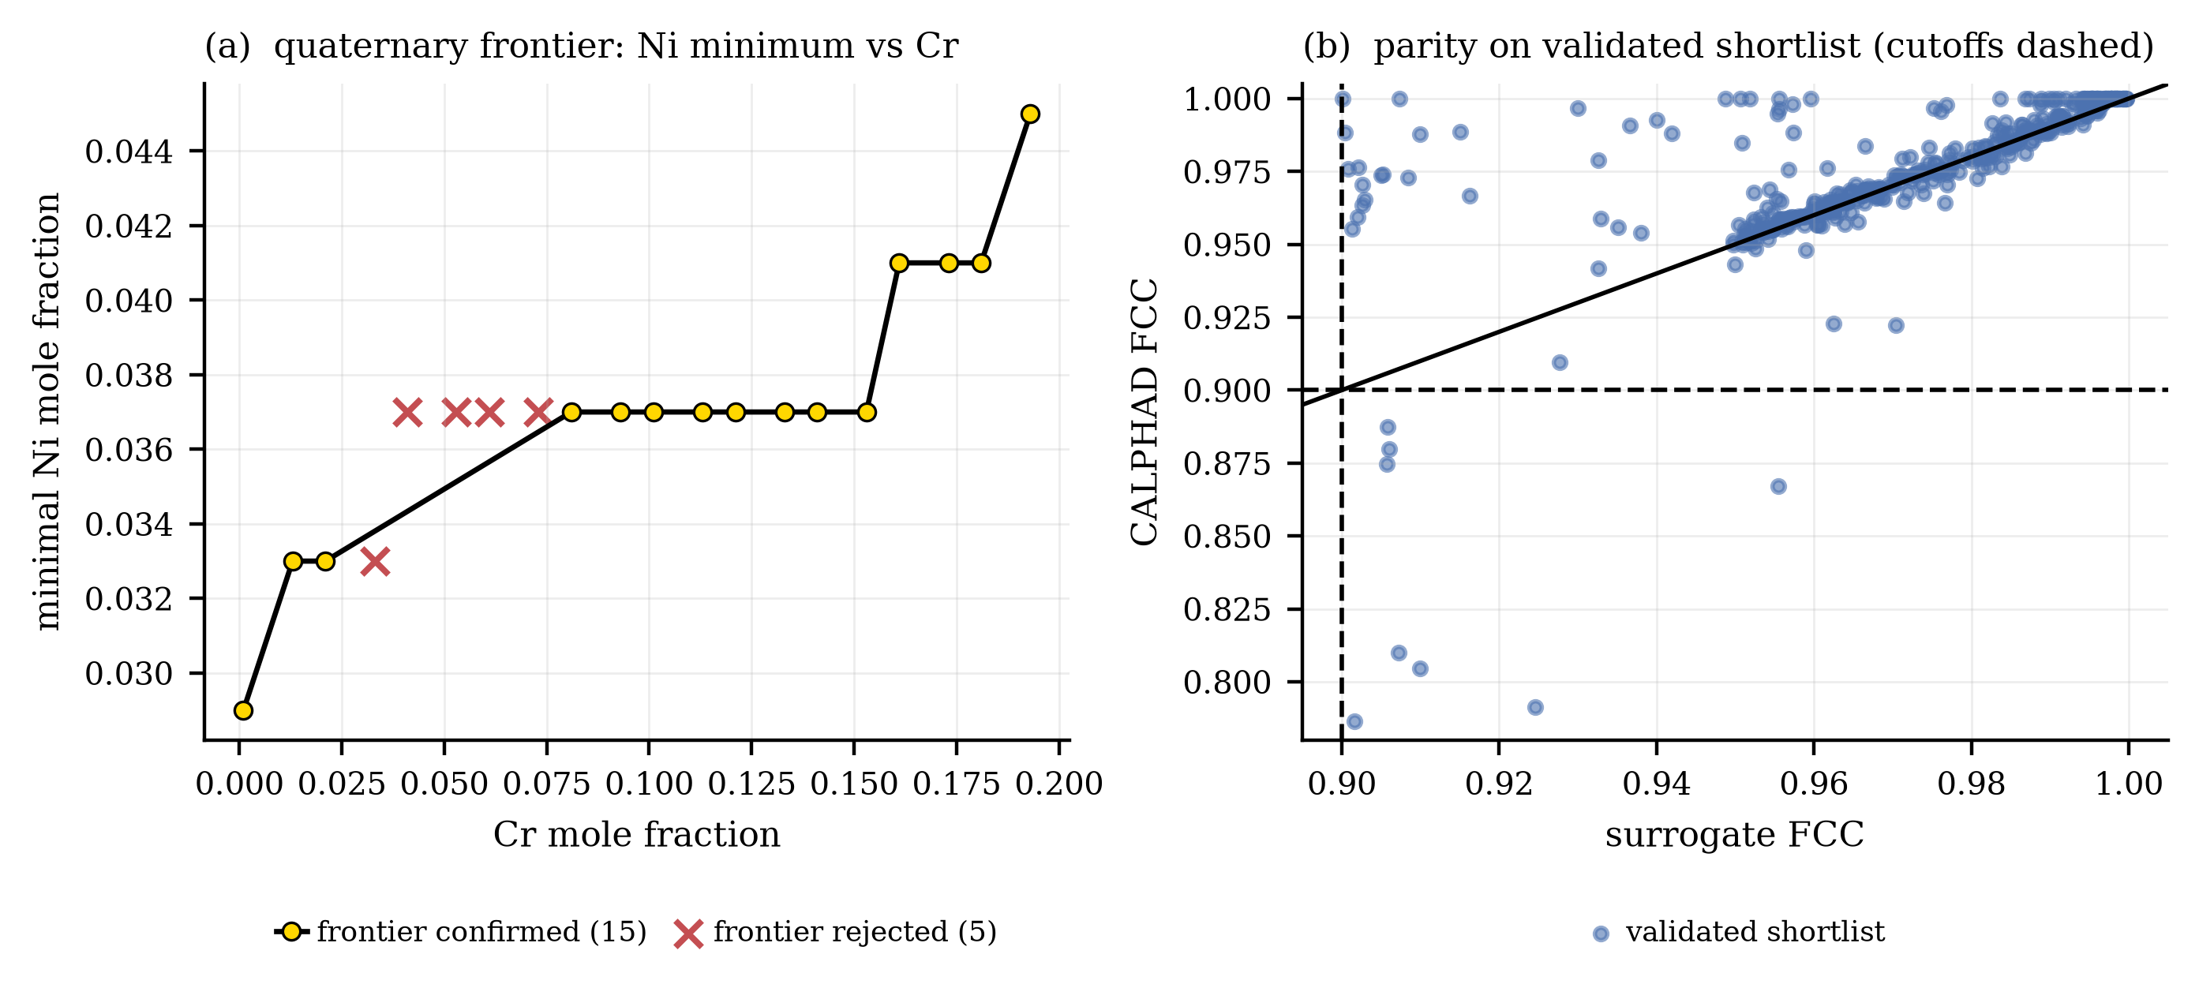
Figure 13. Quaternary screen with carbon at 1000 K. (a) Pareto frontier of minimal Ni versus Cr: 15 of 20 frontier points confirm; the 5 rejections form one contiguous pocket. (b) Surrogate-versus-CALPHAD FCC parity on the validated shortlist.

Discussion

Topological Dependencies and Spatial Concentration of Error
The primary finding from our standard interpolation benchmarking (Table 3, Figure 3) is that the optimal machine learning architecture is not a universal construct; rather, it is fundamentally dictated by the physical-topological characteristics of the underlying thermodynamic phase diagram [10].
In alloy systems dominated by wide, continuously transitioning multi-phase fields, Deep Neural Networks (DNNs) with smooth, structurally constrained output heads (such as standard softmax or train-time sigmoid/$Σ$ normalization) demonstrate clear superiority [4]. This behavior is prominent in the Fe–Cr–Ni, Fe–Cr–Mn, and Fe–Cr–Mo systems. For example, the Fe–Cr–Ni system features a wide face-centered cubic (FCC) solid-solution matrix transitioning smoothly into body-centered cubic (BCC) and topologically close-packed (TCP) $σ$ intermetallics [27, 28]. The continuous, highly differentiable parameterization of Multilayer Perceptrons (MLPs) naturally aligns with these smooth thermodynamic fraction gradients, allowing the network to regress phase fraction shifts with high fidelity.
Conversely, in alloy systems governed by steep, nearly vertical phase boundaries—such as the sharp FCC-to-liquid boundaries in Fe–Mn–Ni or the abrupt BCC-to-$σ$ transitions in Fe–Cr–V—classical tree-based architectures (such as Random Forests and XGBoost) achieve superior interpolation performance [4, 29]. The axis-aligned partitioning logic of decision trees is highly efficient at representing step-like, non-differentiable phase boundaries without artificially smoothing the transitions. However, this topological model dependency reveals a severe limitation: tree-based models lack the smooth extrapolation and continuous interpolation capabilities necessary for multi-scale simulations, such as phase-field modeling [30].
Furthermore, irrespective of the chosen model family, predictive uncertainty is geometrically constrained by the phase diagram topology. By mapping the spatial distribution of the absolute error of our surrogate models (Figure 9), we observe that predictive error is not uniformly distributed across the composition–temperature space. Instead, absolute errors are profoundly concentrated at the phase boundaries—where the active-phase set changes. Under the best-performing constrained MLP (the renorm head in Fe–Cr–Ni), the mean absolute error (MAE) in the spatial tertile closest to a phase boundary averages , whereas the stable interiors of single-phase or multi-phase fields are reproduced with near-perfect precision, averaging (an order of magnitude lower). This spatial concentration of error highlights that surrogate model evaluations should move beyond simple global metrics (such as aggregate MAE) to incorporate spatially resolved topological diagnostics (see Figure 9).

The Reality of Spatial Generalization in Alloy Design
Evaluating machine learning surrogates beyond standard random cross-validation splits is essential for assessing their viability in actual alloy discovery workflows. Random splitting assumes that the test set is independent and identically distributed (i.e., interpolation), but practical alloy design frequently requires navigating "holes" in experimental or computational data, or exploring entirely unprobed chemical spaces [20]. Our spatial generalization protocols explicitly test these out-of-distribution (OOD) boundaries by separating spatial shift penalties from simple data-volume constraints.
Under contiguous, in-hull spatial shifts—simulating missing interior data such as a temperature-band holdout ( K) or a composition-band holdout ()—MLPs degrade much more gracefully than tree-based models. As visualized in Figure 6, the penalty ratio (the ratio of OOD error to a size-matched random control error) remains between and for the constrained MLPs, whereas it spikes up to to for Random Forests and XGBoost. Tree-based models rely on localized leaf-value averages and collapse abruptly near the boundaries of missing bands, returning step-like predictions that are highly unphysical. In contrast, the continuous mathematical representations of MLPs bridge these spatial gaps smoothly, making them far more robust for "filling in" missing thermodynamic coordinate spaces.
However, this graceful in-hull degradation must not be conflated with true thermodynamic extrapolation. When subjected to strict, out-of-range, one-sided extrapolation (e.g., training on and testing on , or training on K and testing on K), predictive accuracy collapses catastrophically across all architectures. Absolute MAEs on the far-side climb to to , representing a 10-to-20-fold degradation compared to matched interpolation controls (Figure 7). This severe degradation aligns with extensive out-of-distribution materials informatics benchmarks of over 700 OOD tasks, which show that standard deep learning architectures struggle with true extrapolation because the target spaces fall outside their representational support. Merely scaling up dataset size or training time yields diminishing returns in these extrapolative regimes, necessitating alternative transductive architectures that learn relative property changes rather than absolute values, or deep generative flow-based models to "imagine" missing boundaries [23]. The ideal-form control sharpens this picture into an operational rule. At equal training size, removing a contiguous band still doubles the error on average (0.93–3.84, mean 2.01), while equal-size subsampling elsewhere changes it by only 3%. Error therefore tracks data coverage, not data volume. For screening loops, coverage of the query region matters more than sheer dataset size, and the constrained MLP degrades least in nine of ten band–system combinations.

Thermodynamic Fidelity versus Numerical Emulation
To establish a rigorous epistemic foundation for materials informatics, we must distinguish between thermodynamic physical truth and numerical emulation. A machine learning surrogate is not a physical theory; it is strictly a high-speed numerical emulator trained to approximate the outputs of an underlying CALPHAD solver, executing the mapping:
$$\left(x,T\right)→y_{\text{CALPHAD}}$$
Consequently, the surrogate model intrinsically inherits all underlying thermodynamic assumptions (such as global equilibrium postulates) and databases (such as MatCalc mc_fe_v2.062) used to generate the training data. High accuracy on a test partition simply confirms that the neural network has successfully emulated the solver's numerical optimization to float32 precision. It does not validate the physical accuracy of the CALPHAD model itself. For example, if a CALPHAD database fails to capture a metastable phase due to a lack of assessed binary or ternary interaction parameters [8], the surrogate will mathematically replicate this blind spot.
This distinction emphasizes the role of surrogates as high-speed screening filters rather than thermodynamic arbiters. While the -fold speedups provided by MLPs enable the screening of multi-million composition databases in seconds, any candidate alloy identified during high-throughput screening must be independently re-validated using direct CALPHAD calculations and, ultimately, targeted experimental synthesis. The two validated screens quantify the filter economics. Break-even near 10⁴ points against payback of 7–50 times (ternary) and 10–30 times (quaternary) in a single query, with shortlist precision 1.00 and 0.98 and recall ~0.8 on both. The boundary conditions stand: one temperature each on two systems, and trusting the screen still requires spot CALPHAD — the screens above spent about 11,000 full-set solves on validation.

The Metallurgy of the Regressor–Detector Gap
A critical, often neglected issue in materials informatics is the "regressor–detector gap," where models optimized for continuous regression (lowest overall MAE) act as poor phase-presence detectors [24]. In physical metallurgy, minor or rare phases exercise a disproportionate influence on an alloy's properties. For example, the presence of trace intermetallics (such as the embrittling $σ$-phase in stainless steels) or minor reinforcing carbides can completely alter mechanical strength, creep resistance, and corrosion properties [31, 32].
From a machine-learning perspective, these rare phases are cheap in terms of global loss calculations. Because zero-fraction rows mathematically dominate the multi-phase alloy database (as candidate phases are absent across vast composition–temperature coordinates), a model can achieve a deceptively low aggregate MAE of $0.007$ by predicting near-zero fractions for inactive phases, while entirely failing to resolve the stabilizing boundaries of rare, trace, or minor phases.
As detailed in Table 6, this leads to a stable discrepancy: in the Fe–Cr–Mn system, the MLP achieves the lowest continuous regression error yet the random forest is the better detector; in the Fe–Mn–Ni system, the random forest wins both tasks, while the MLP exhibits an exceptionally poor $F_{1}$ score ($0.312$) and fails to detect three rare phases entirely (MNNI, MNNI2, and ALPHA_MN). In contrast, the random forest pairs the lowest continuous error in that system with a significantly more robust detector ($F_{1}$ score of $0.504$). This regressor–detector gap is robust across varying classification thresholds (${10}^{-4}$ to ${10}^{-2}$), and more importantly, discrete phase-presence detection capability degrades much faster than continuous regression error when the model is subjected to spatial distribution shifts. This finding suggests that future materials informatics workflows must utilize multi-criteria validation, incorporating classification-based metrics (such as $F_{1}$ scores and balanced accuracy) alongside continuous regression errors to build reliable surrogates.

Limitations and Mechanistic Insights from Negative Results
A primary value of this study lies in the detailed characterization of negative results, which establishes clear mathematical boundaries and prevents redundant developmental efforts in materials informatics. Three theoretically plausible constraint mechanisms failed to perform reliably:
- Sparsemax Operator (Figure 8a): While sparsemax mathematically projects logits onto the simplex to output exact zeros, it exhibited severe seed sensitivity. The resulting inter-seed variance was on the same order of magnitude as the mean MAE. This behavior is consistent with the hypothesis that gradients vanish identically once a logit drops below the threshold, trapping the network in poor initial local minima and making training highly unstable.
- Sum-to-One Soft Optimization Penalty (Figure 8b): Attempting to enforce mass-balance closure strictly as a regularizing loss term (e.g., or ) created pathological competition with the regression targets. It purchased partial closure entirely at the expense of model fit, degrading the overall MAE by a factor of 8 to 16. For the tested formulation and penalty weights, the soft penalty was redundant and strongly detrimental; structural output layers achieved numerical closure without sacrificing the fit.
- Residue Closure Head (Figure 8c): Algebraically deducing the -th phase fraction as a residual () accumulated all individual neural prediction errors into a single, unconstrained channel. This led to massive error accumulation in the designated residual phase and frequently produced physically inadmissible negative fractions; under the evaluated configuration, this asymmetrical closure formulation proved unviable.
Several protocol-level caveats bound the generality of these findings. The contiguous-band holdout is a missing-region test inside the sampled domain, and the strict extrapolation protocol is one-sided, covering only one coordinate at a time; behavior beyond the sampled simplex remains unvalidated. The design distribution is deliberately structured, not uniform, so all reported average errors are expectations under that sampling distribution, and rankings could shift under a different prior. All MLPs share one fixed architecture and all baselines use fixed hyperparameters: the comparison is a fixed-protocol benchmark, not an exhaustive hyperparameter search, and the reported MLP is not architecture-optimal. The mean ± standard deviation over three seeds quantifies seed-to-seed training stochasticity only, not total predictive uncertainty. The phase-boundary analysis uses an empirical boundary proxy — the distance to the nearest sampled row with a different active-phase set — not the exact thermodynamic distance to a phase boundary. Finally, the sparsemax and penalty conclusions are scoped to the tested hyperparameters, and the comparison set is not exhaustive over function classes.
Another significant limitation of our current surrogate pipeline is its dependence on a predefined, closed phase set () determined prior to modeling. This static basis prevents the model from predicting or discovering previously unseen phases in unprobed compositional regions. Furthermore, our study did not apply log-ratio Compositional Data Analysis (CoDA) methods, such as the Centered Log-Ratio (CLR) or Isometric Log-Ratio (ILR) transformations, which are standard in geochemistry [15] and plant nutrition [16]. While CoDA elegantly handles simplex constraints, its mathematical formulations contain logarithmic terms that are undefined at zero. Managing the "structural zeros" (phases that are physically absent) which dominate multi-phase metallurgical equilibria remains a massive challenge for CoDA, representing an exciting and vital direction for future scientific machine learning research. Three further bounds apply. Only one solver generated all labels, so solver disagreement is unexplored. All nine systems come from one assessed steel database, which isolates model behavior from database variation but holds database error fixed. The gated remedy was evaluated under shift on two systems only, with one composition-extrapolation reversal.

Conclusions
This study benchmarked six neural network output heads and four classical machine learning baselines across five Fe-based ternary systems, utilizing a mass-balance-validated dataset of 44,397 equilibria. The principal conclusions are as follows:
- Strict Constraint Adherence: Structurally constrained neural architectures—specifically softmax, sigmoid/$Σ$, and renorm heads—satisfy the full probability simplex constraint (mass-balance closure and strict non-negativity) natively at float32 precision without compromising regression accuracy. Unconstrained networks yield physically inadmissible outputs, violating closure by up to 8%.
- Topological Model Dependency: Model superiority is highly dependent on the phase diagram's topology. MLPs excel in systems dominated by continuous, smooth phase coexistence fields, whereas random forests outperform in systems defined by sharp, binary phase boundaries.
- The Regressor–Detector Gap: Regression accuracy does not guarantee reliable classification. The model yielding the lowest aggregate MAE may fail to detect trace phases, a vulnerability that becomes sharply pronounced under spatial distribution shifts.
- Extrapolation Limits: While structurally constrained MLPs exhibited more robust in-hull spatial generalization compared to localized tree ensembles, true out-of-range extrapolation triggered severe, order-of-magnitude error degradation across all tested architectures.
Presence supervision closes the gap. The gated two-stage head lifts macro-AUPRC to 0.91–0.99 on all nine systems (best classical detector beaten on eight) while leading the forest in MAE. Presence supervision, not architecture, resolves the sharp-boundary cases.
Penalties are spatial, not volumetric. The ideal-form control holds training size fixed and still doubles the error on band removal (mean 2.01) against a 3% size effect. Error tracks coverage, and strict extrapolation remains unsupported on every axis tested.
Generality across dimension and chemistry. Rankings, gap, remedy, and protocols transfer to a quaternary, a carbide ternary, and two Fe-free ternaries (88,542 equilibria total). The sparse head is competitive only on dilute nine-phase targets.
Screening pays. Two validated lean-nickel screens (501,501 and 330,000 compositions; precision 1.00 and 0.98) pay back data costs several times over, with ensemble disagreement as a shortlist triage gate and a four-point experimental anchor bounding database disagreement.

Code and Data Availability
The code and data supporting the findings of this study are publicly available on GitHub: https://github.com/user4072/CALPHAD-based-Phase-Fraction-Prediction

CRediT Author Statement
- Sina Mousavi: Conceptualization, Methodology, Software, Data curation, Formal analysis, Investigation, Visualization, Writing – original draft, Project administration.
- Narinderjit Singh Sawaran Singh: Methodology, Formal analysis, Validation, Writing – review & editing, Supervision.
- Darya Ahmadova: Data curation, Investigation, Validation, Writing – review & editing.
- Sandeep Sharma: Formal analysis, Investigation, Validation, Writing – review & editing.
- Sanjeev Singh: Investigation, Resources, Validation, Writing – review & editing.
- Qasem Kharmah: Formal analysis, Validation, Writing – review & editing, Supervision.

Declaration of interests
The authors declare that they have no known competing financial interests or personal relationships that could have appeared to influence the work reported in this paper.

Funding
The authors did not receive support from any organization for the submitted work.

References
1. Yi Wang, W., et al., Integrated computational materials engineering for advanced materials: A brief review. Computational Materials Science, 2019. 158: p. 42-48.
2. Bordonhos, M., et al., Multiscale Computational Approaches toward the Understanding of Materials. Advanced Theory and Simulations, 2023. 6(10): p. 2200628.
3. Xi, S., et al., Phase diagram construction and prediction method based on machine learning algorithms. Journal of Materials Research and Technology, 2025. 36: p. 1917-1929.
4. Liu, S., et al., A comparative study of predicting high entropy alloy phase fractions with traditional machine learning and deep neural networks. npj Computational Materials, 2024. 10(1): p. 172.
5. Connolly, J.A.D., A primer in gibbs energy minimization for geophysicists. Petrology, 2017. 25(5): p. 526-534.
6. Kim, S.W., et al., Estimating the phase volume fraction of multi-phase steel via unsupervised deep learning. Scientific Reports, 2021. 11(1): p. 5902.
7. Xie, C., et al., From processing text to counterfactual steel design: a knowledge-graph-organized and reliability-aware machine learning framework. Materials & Design, 2026: p. 116691.
8. Tahkola, M., et al., Accelerated discovery of Cr-based A2+B2 superalloys across 11 elements with a deep-learning CALPHAD surrogate. npj Computational Materials, 2026.
9. Li, S., et al., Unsupervised Machine Learning Guides the Design of MnFeCoNiMg High-Entropy Alloys for Optimizing MoS2 Interface Properties. Journal of Materials Research and Technology, 2026.
10. Vazquez, G., et al., A deep neural network regressor for phase constitution estimation in the high entropy alloy system Al-Co-Cr-Fe-Mn-Nb-Ni. npj Computational Materials, 2023. 9(1): p. 68.
11. Yu, W., et al., Integrated design of hardness and weldability for multi-component Fe-based hardfacing alloys driven by machine learning and high-throughput computation. Journal of Materials Research and Technology, 2026. 42: p. 11496-11509.
12. Mayr, L.M. and D. Bojanic, Novel trends in high-throughput screening. Current Opinion in Pharmacology, 2009. 9(5): p. 580-588.
13. Zhang, T., et al., A self-adaptive deep learning algorithm for accelerating multi-component flash calculation. Computer Methods in Applied Mechanics and Engineering, 2020. 369: p. 113207.
14. Ben Hicham, K.K., et al., Differentiable Thermodynamic Phase-Equilibria for Machine Learning. Journal of Chemical Information and Modeling, 2026.
15. Meloni, F., et al., Integrating Compositional Data Analysis (CoDA) and Random Forest for lithology-specific geochemical baseline determination. Science of The Total Environment, 2026. 1011: p. 181169.
16. Parent, L.E., Compositional and Machine Learning Tools to Model Plant Nutrition: Overview and Perspectives. Horticulturae, 2025. 11(2): p. 161.
17. Karthik, M.R. and T.B. Rao, Physics-informed data-driven ensemble and transfer learning approaches for prediction of temperature field and cutting force during machining IN625 superalloy. International Journal on Interactive Design and Manufacturing (IJIDeM), 2025. 19(10): p. 7027-7060.
18. Agrawal, A. and A. Choudhary, Perspective: Materials informatics and big data: Realization of the “fourth paradigm” of science in materials science. APL Materials, 2016. 4(5).
19. Ward, L. and C. Wolverton, Atomistic calculations and materials informatics: A review. Current Opinion in Solid State and Materials Science, 2017. 21(3): p. 167-176.
20. Li, K., et al., Probing out-of-distribution generalization in machine learning for materials. Communications Materials, 2025. 6(1): p. 9.
21. Segal, N., et al., Known Unknowns: Out-of-Distribution Property Prediction in Materials and Molecules. npj Computational Materials, 2025. 11(1): p. 345.
22. Li, X., et al., Combining transfer learning and statistical measures to predict performance of composite materials with limited data. Computer-Aided Civil and Infrastructure Engineering, 2025. 40(6): p. 817-838.
23. Hatakeyama-Sato, K. and K. Oyaizu, Generative Models for Extrapolation Prediction in Materials Informatics. ACS Omega, 2021. 6(22): p. 14566-14574.
24. Speckhard, D.T., et al., Extrapolation to the complete basis-set limit in density-functional theory using statistical learning. Physical Review Materials, 2025. 9(1): p. 013801.
25. Li, Y., et al., Towards high-throughput microstructure simulation in compositionally complex alloys via machine learning. Calphad, 2021. 72: p. 102231.
26. Rahnama, A., S. Clark, and S. Sridhar, Machine learning for predicting occurrence of interphase precipitation in HSLA steels. Computational Materials Science, 2018. 154: p. 169-177.
27. Hao, S., et al., Developing reliable machine learning interatomic potential for Fe–Cr–Ni austenitic alloys. Journal of Applied Physics, 2025. 138(8).
28. Panchal, J.H., S.R. Kalidindi, and D.L. McDowell, Key computational modeling issues in Integrated Computational Materials Engineering. Computer-Aided Design, 2013. 45(1): p. 4-25.
29. Song, Y., et al., Prediction of clathrate hydrate phase equilibria using gradient boosted regression trees and deep neural networks. The Journal of Chemical Thermodynamics, 2019. 135: p. 86-96.
30. Eiken, J., B. Böttger, and I. Steinbach, Multiphase-field approach for multicomponent alloys with extrapolation scheme for numerical application. Physical Review E—Statistical, Nonlinear, and Soft Matter Physics, 2006. 73(6): p. 066122.
31. Anburaj, J., et al., Ageing of forged superaustenitic stainless steel: Precipitate phases and mechanical properties. Materials Science and Engineering: A, 2012. 535: p. 99-107.
32. Aditya, D.M., et al., The study of sigma and carbide in cast austenitic stainless-steel grade HH after 24 years of high-temperature service. Heliyon, 2023. 9(3).
33. Stoco, C.B., et al., Accelerating phase prediction via CALPHAD-informed machine learning and data augmentation. Computational Materials Science, 2026. 272: p. 114834.
34. Otis, R. and Z.-K. Liu, pycalphad: CALPHAD-based computational thermodynamics in Python. Journal of Open Research Software, 2017. 5: p. 1.
35. MatCalc, Open thermodynamic databases. 2023. https://www.matcalc.at/.
36. Drozdov’a, L’., et al., Temperatures of liquidus, solidus and peritectic transformation of Fe–C–Cr based alloys. In: METAL 2017 — 26th International Conference on Metallurgy and Materials, Brno, Czech Republic, 2017. pp. 65–70.
37. Yamada, A., et al., Determination of liquidus and solidus surfaces at iron-rich region of Fe–Cr–Ni system. Tetsu-to-Hagan’e, 1987. 73: pp. 1676–1683.

